**On-Premise Data Migration Project Using Azure**

Project Description:

Tools Used: **Azure Data Factory, Azure Synapse Analytics, Azure Databricks, Azure Data Lake storage, Azure Key Vault, Azure Active Directory, SQL Server, PowerBI**

* The main objective of the project is to move all the tables from the on-premise SQL server to Azure.
* Created Azure Data factory pipeline to migrate the data from on-premise to Azure by using Azure self-hosted integration runtime.
* Used Lookup, For each and copy activity within ADF to iteratively move all the tables from on-premise to Azure by using the dynamic content option.
* Configured appropriate source, sink, and file format options while moving the data into Azure Data Lake Gen 2.
* Then used Azure Databricks to transform the data by categorizing them into bronze, silver, and gold layers by mounting the Azure Data Lake gen2 by creating the app registration, and then adding the role assignment.
* Integrated this Azure data bricks notebook in the ADF to automatically do the transformation once they are available at the source.
* To analyze the cleaned data we used Azure Synapse Analytics. We mounted the gold container which has the cleaned data.
* Created another pipeline in the Synapse which uses the get metadata, for each and stored procedure activity to dynamically create the view for all the files present in the ADLS.
* Once we created the view we analyzed the data to get insights from the data using a serverless SQL pool.
* To build the interactive visualization we use PowerBI. We connected the PowerBI with the Synapse analytics using the Synapse SQL server endpoint and then visualized the data in PowerBI.
* Used Azure key vault and active directory in managing and safeguarding cryptographic keys and user access.

**Data Architecture**

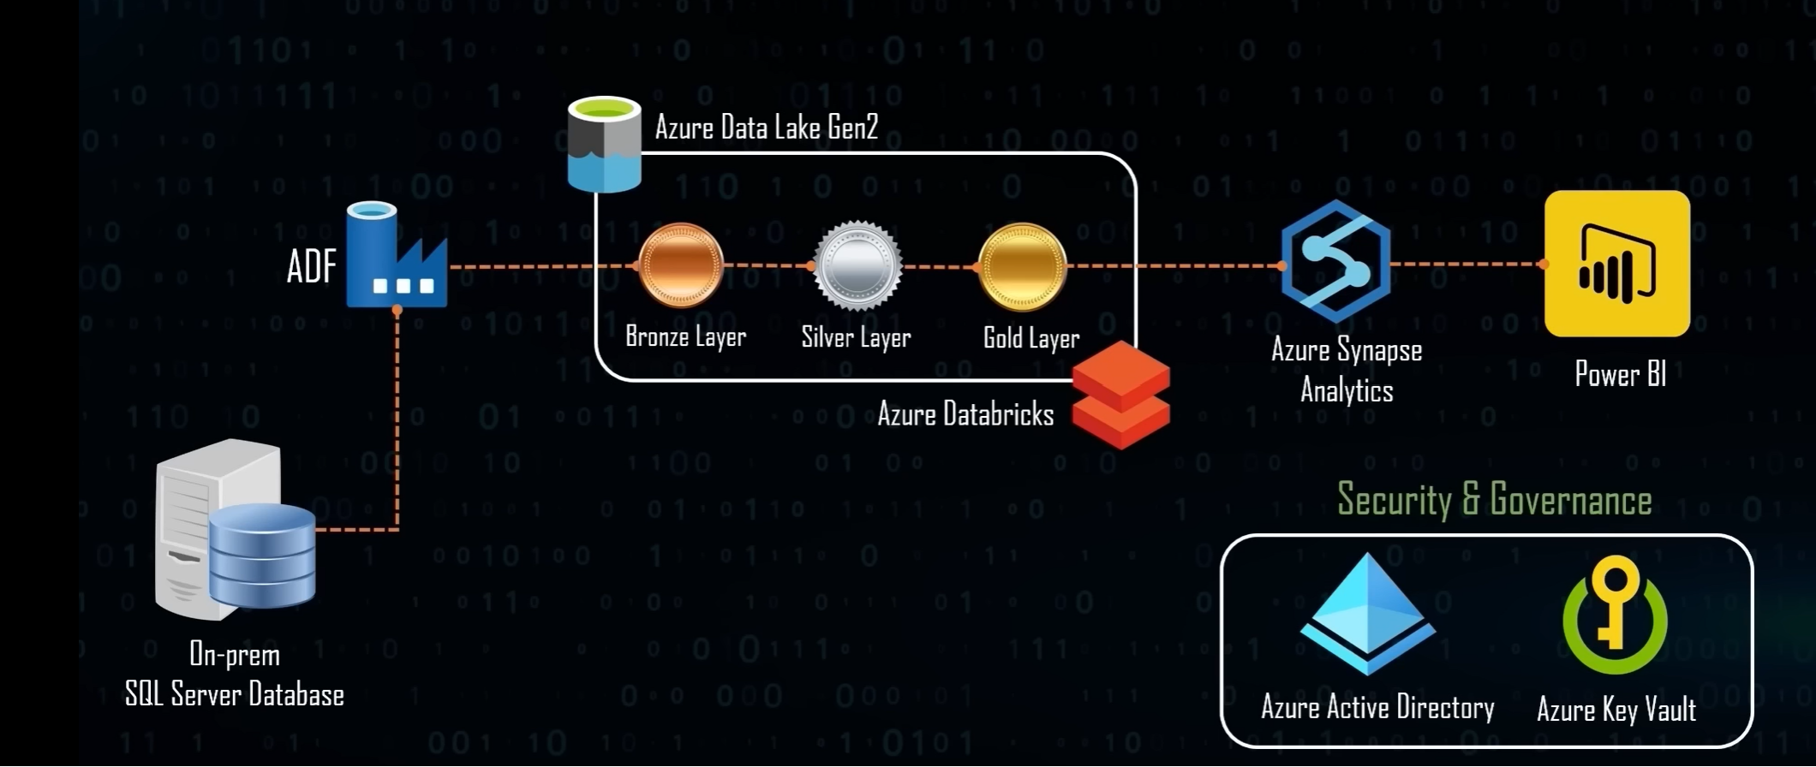

AdventureWorks Database – On-premise SQL DB

* Create a login for the on-premise database and use this username and password to connect to the cloud.

create login akshay_user with password = 'Akshay@123'

create user akshay_user for login akshay_user.

* Assign a role to this user

Security -> users -> right-click on the user -> properties -> Memberships -> Assign db_datareader role to this user.

* Store this password in the key vault

Key vault -> Secret -> Generate /Import -> Store the username and password in the key vault

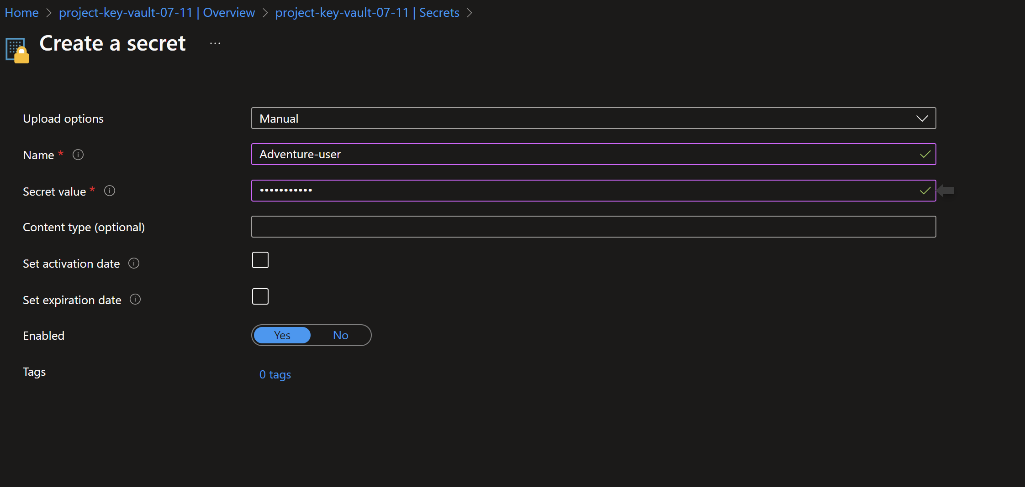

* Added role assignment -Azure key vault administrator ( Because its gives error – Denied with no valid RBAC)

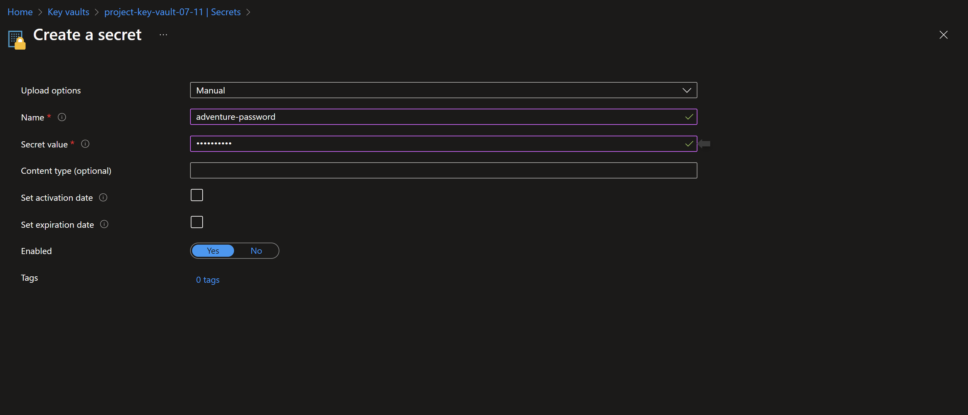

**Data Ingestion:**

* To connect the Azure data factory and the on-premise SQL DB we need to install on-premise integration runtime in the device where SQL DB is hosted.

Manage -> Integration runtime -> New -> Select Azure self-hosted -> Select self-hosted ->

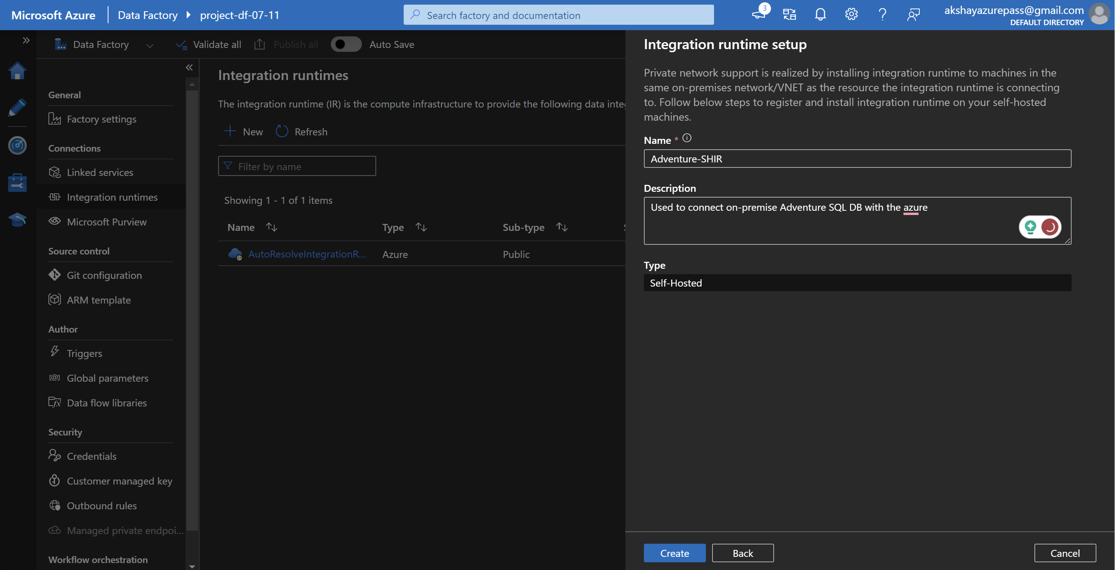

Select option 1 -> Express Setup -> Download the exe file and Run it locally.

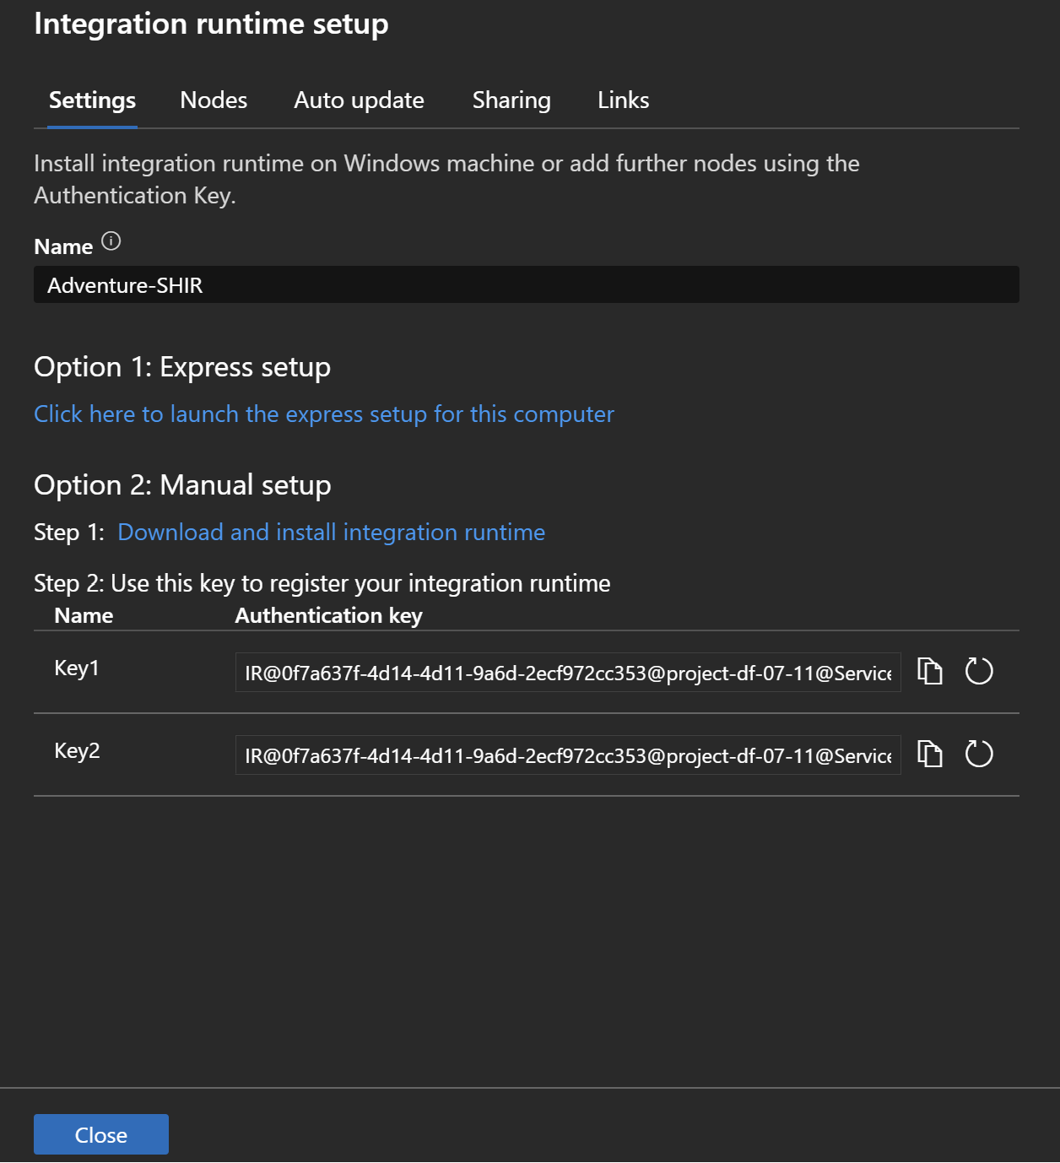

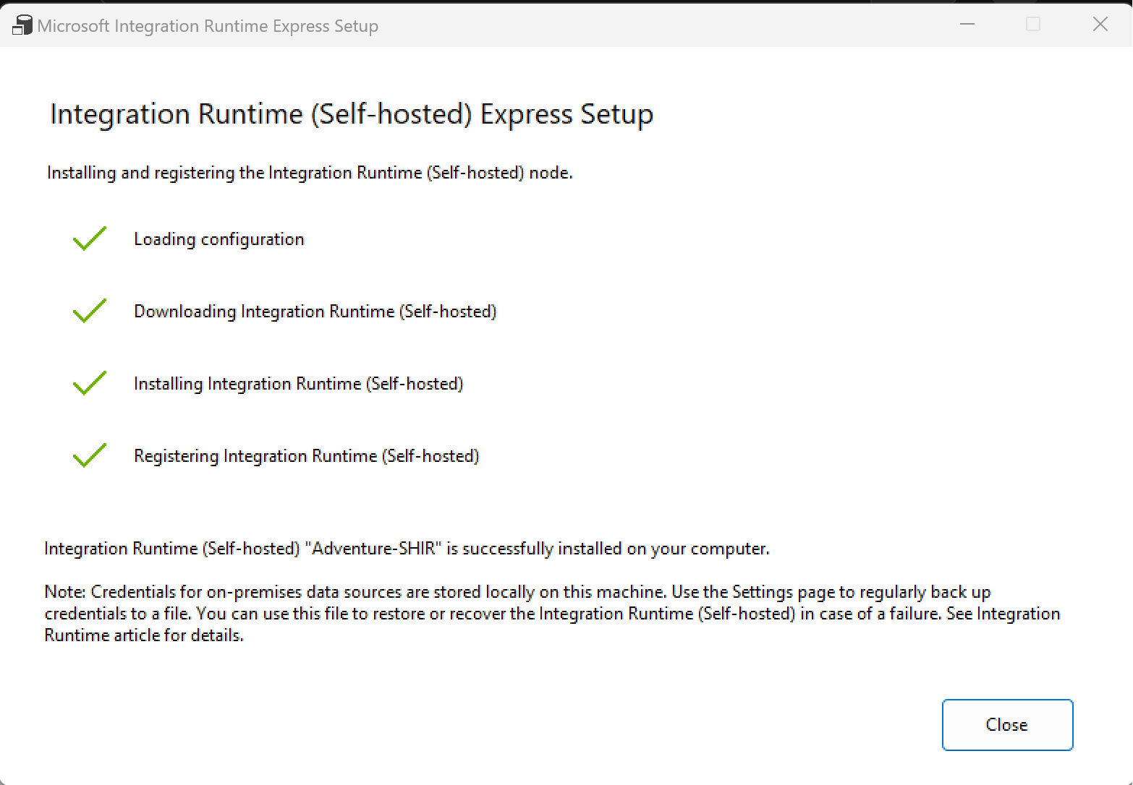

**Building Data Pipeline Using Azure Data Factory.**

* Create a new pipeline in the ADF.
* Use the Copy data activity

Source -> Select the SQL server and self-hosted integration runtime

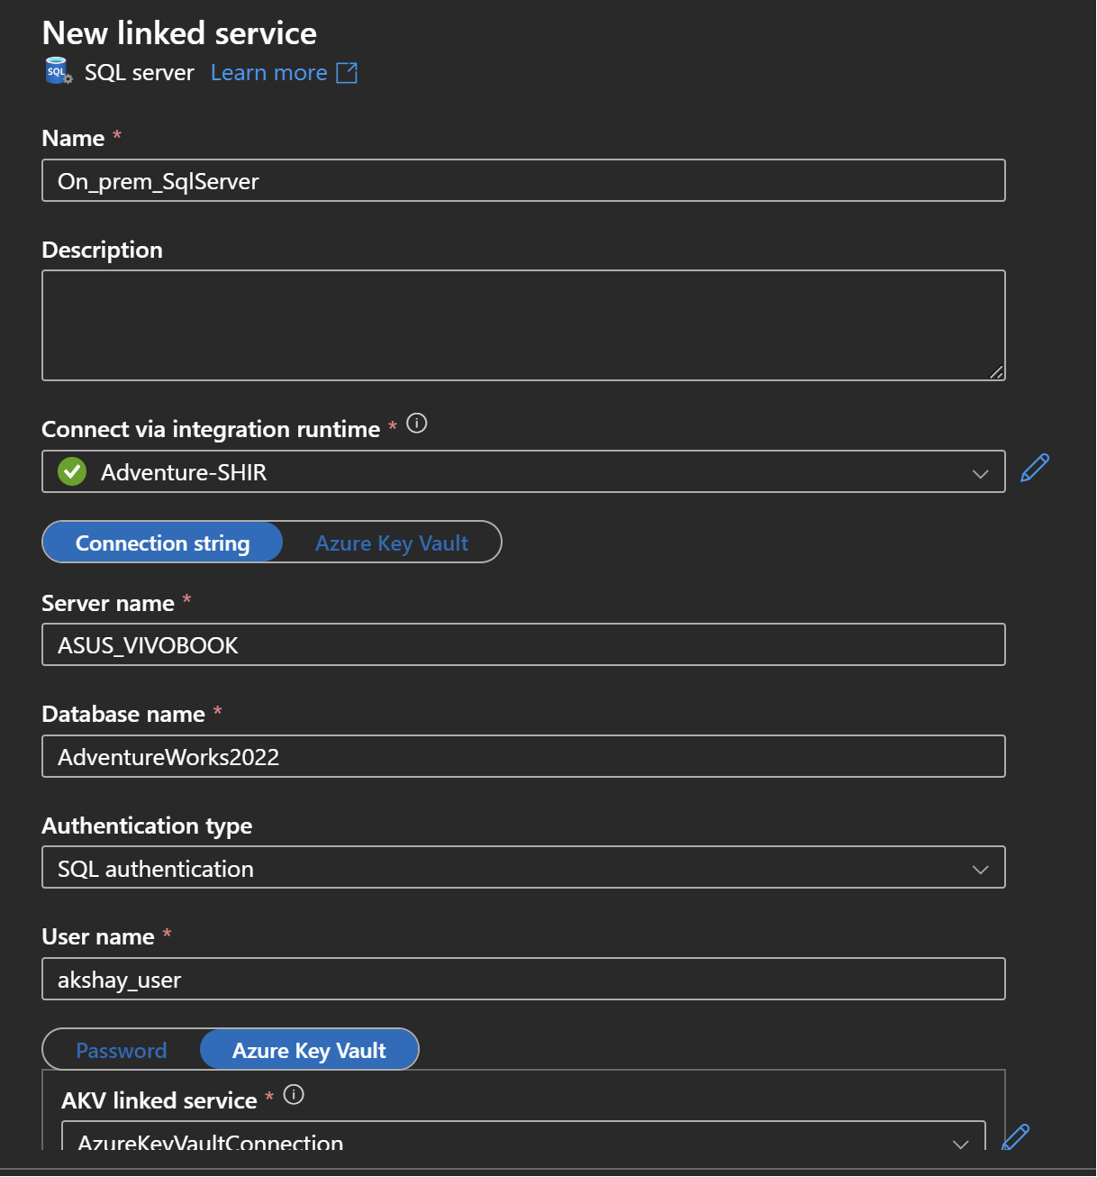

To get the server name -> click on connect -> Database Engine -> Server name

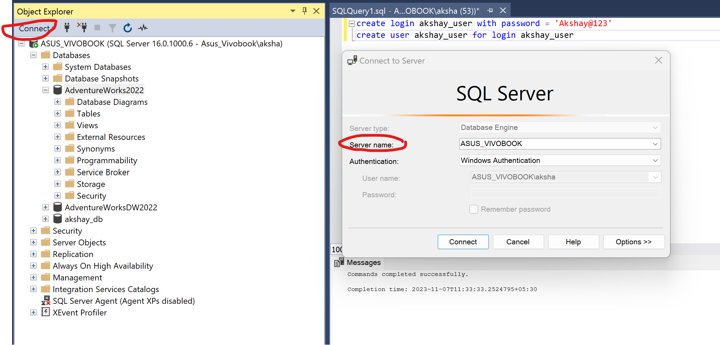

* Enter the username and for the password select the key vault service
* Create the new key vault-linked connection
* The connection will be successful and we cannot list the secrets created in the key vault because the data factory doesn’t have permission to access the key vaults.
* To resolve this go to IAM within a key vault.

Add role assignment -> Give the key vault admin role -> Select managed identity -> Select Azure data factory

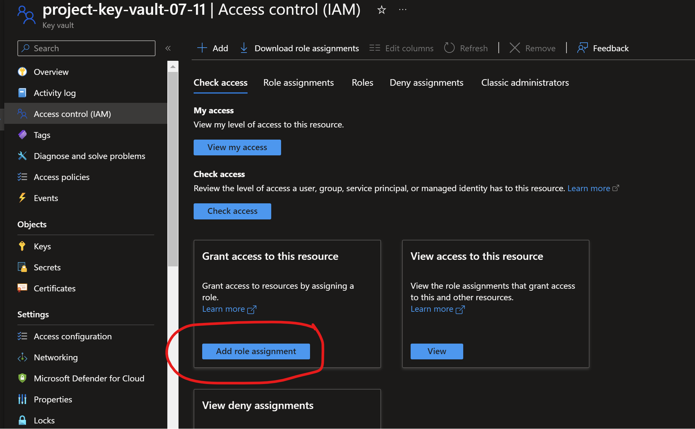

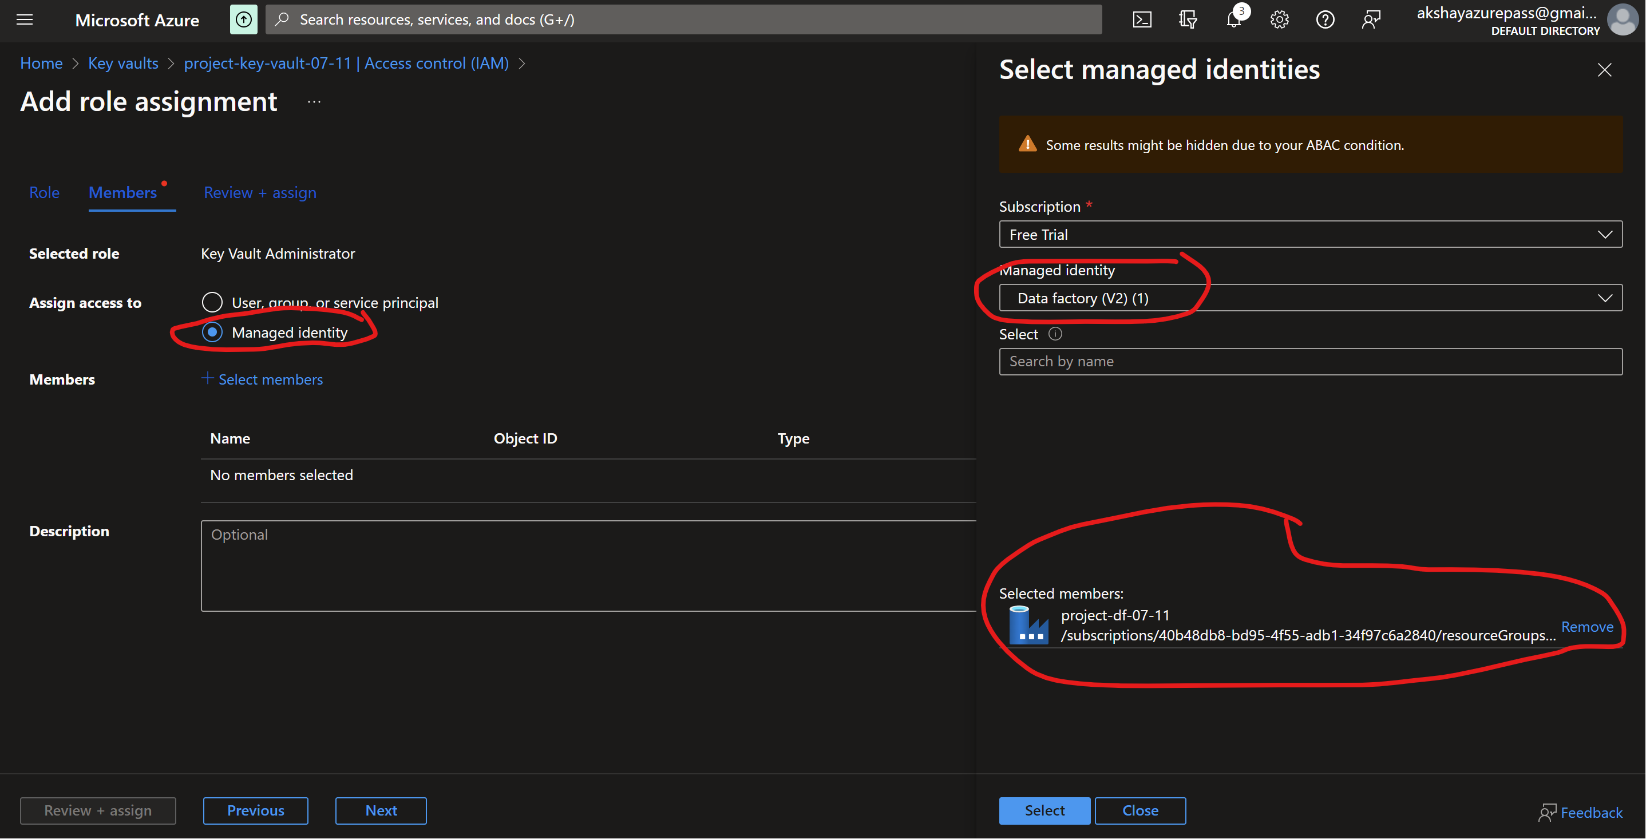

* Create a new pipeline to load all the files from on-prem to the Azure Data Lake Gen 2

Use the lookup activity

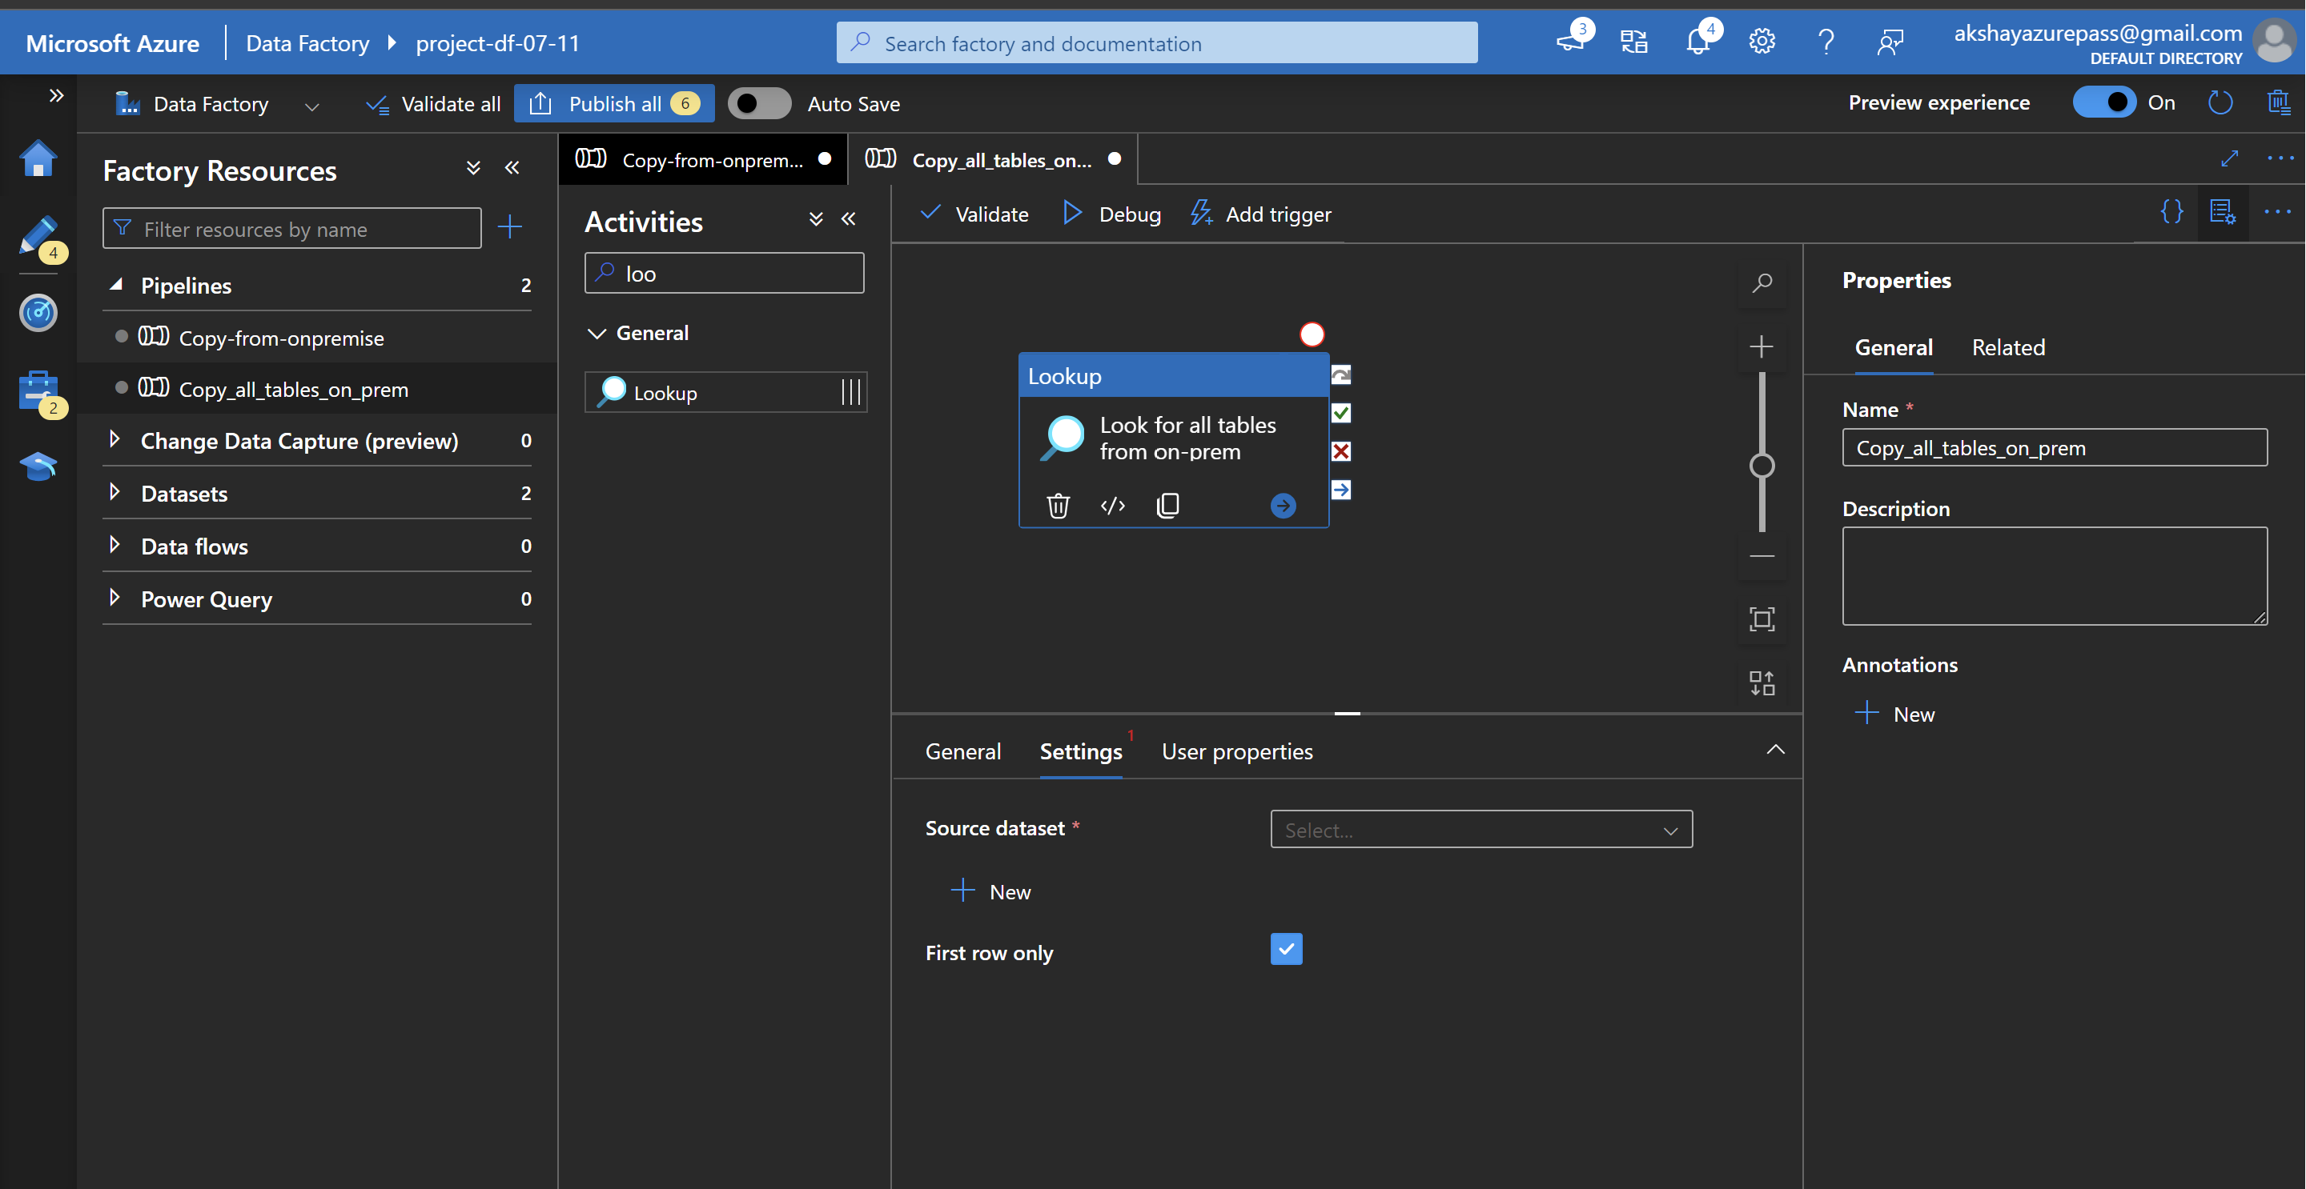

Settings -> New -> Select SQL Server -> Don’t select any tables on the linked connection page.

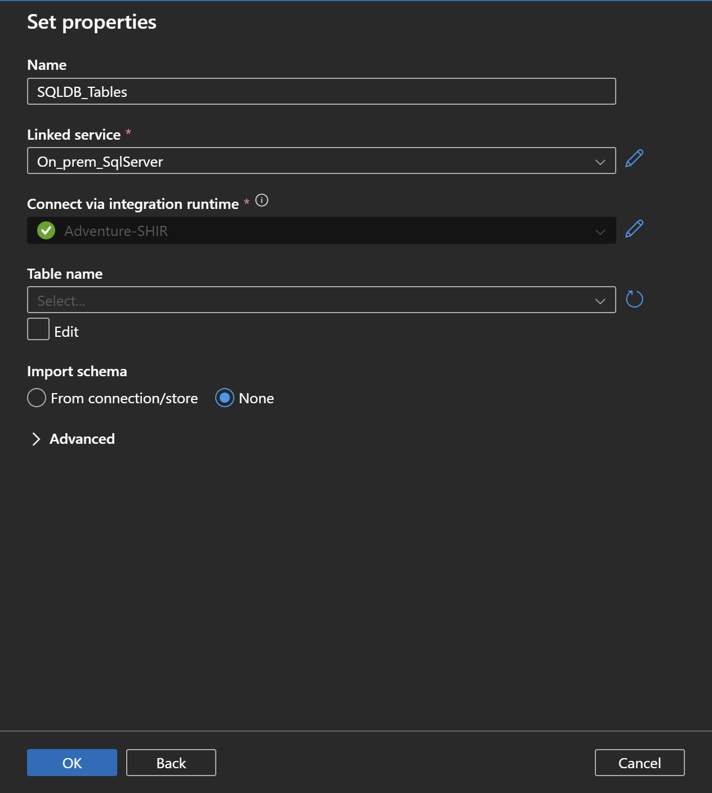

* Select the query option and write this query and disable the first row only option.

select

s.name as SchemaName ,

t.name as TableName

from sys.tables t

inner join sys.schemas s

on s.schema_id = t.schema_id

order by 1

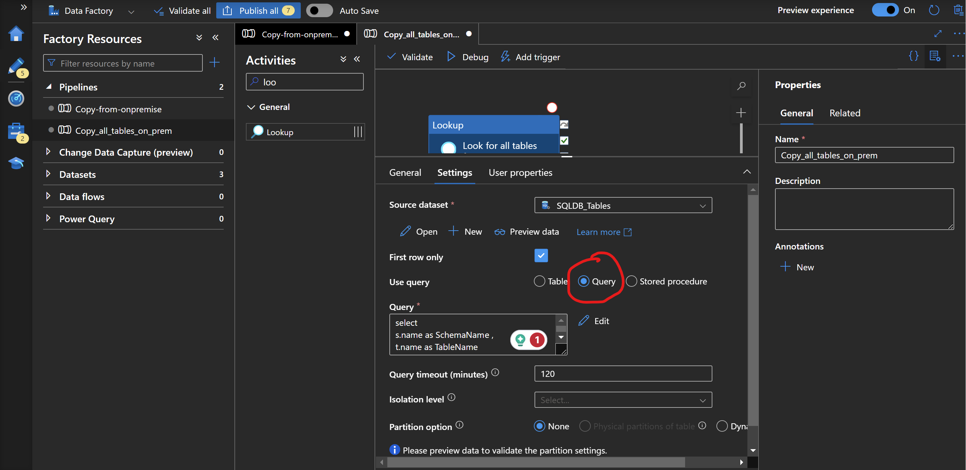

The lookup will return all the tables ( 72 tables)

* Next use the ForEach activity

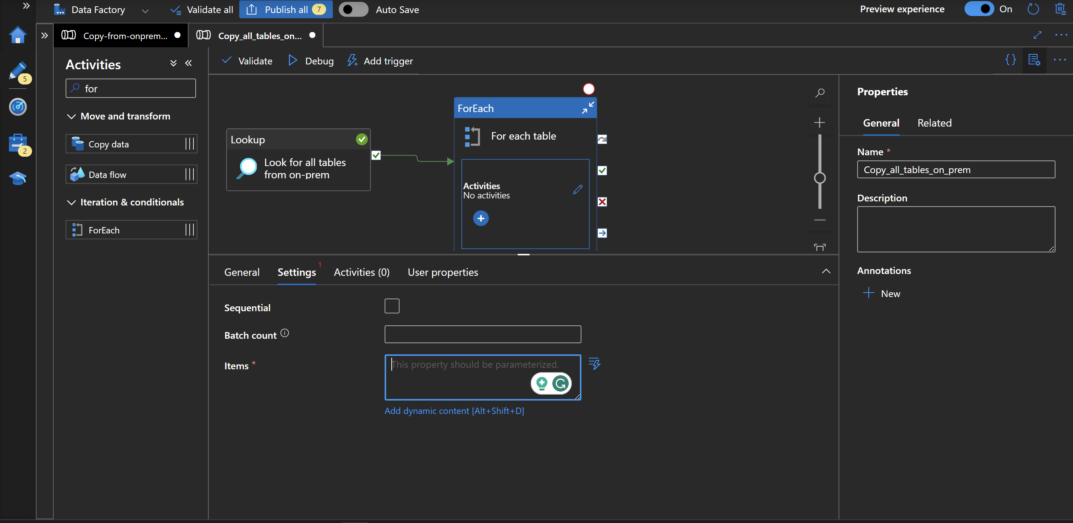

Settings -> Add dynamic Content -> Select Look for all tables from on-prem (first option)

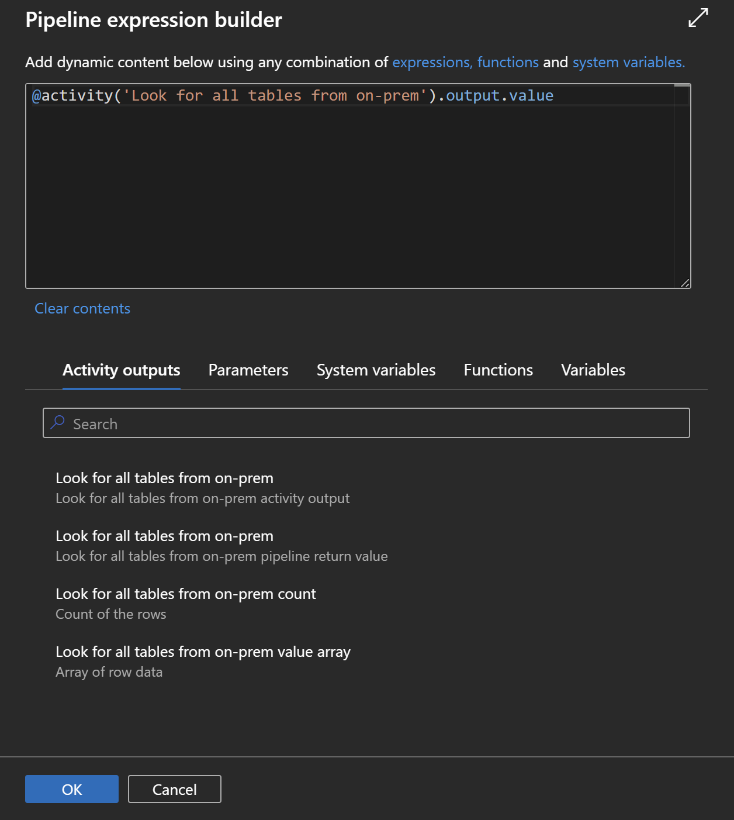

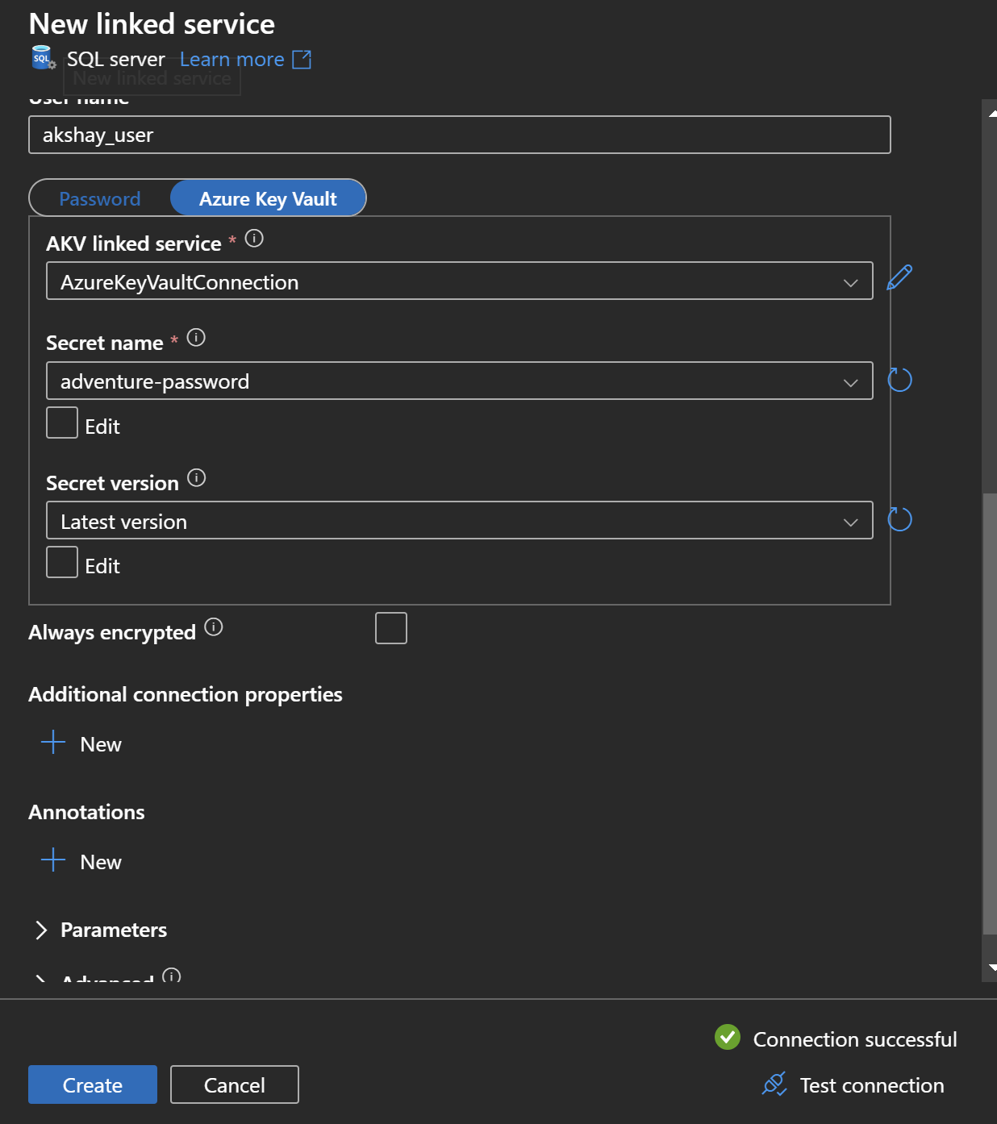

Go to activity -> Edit

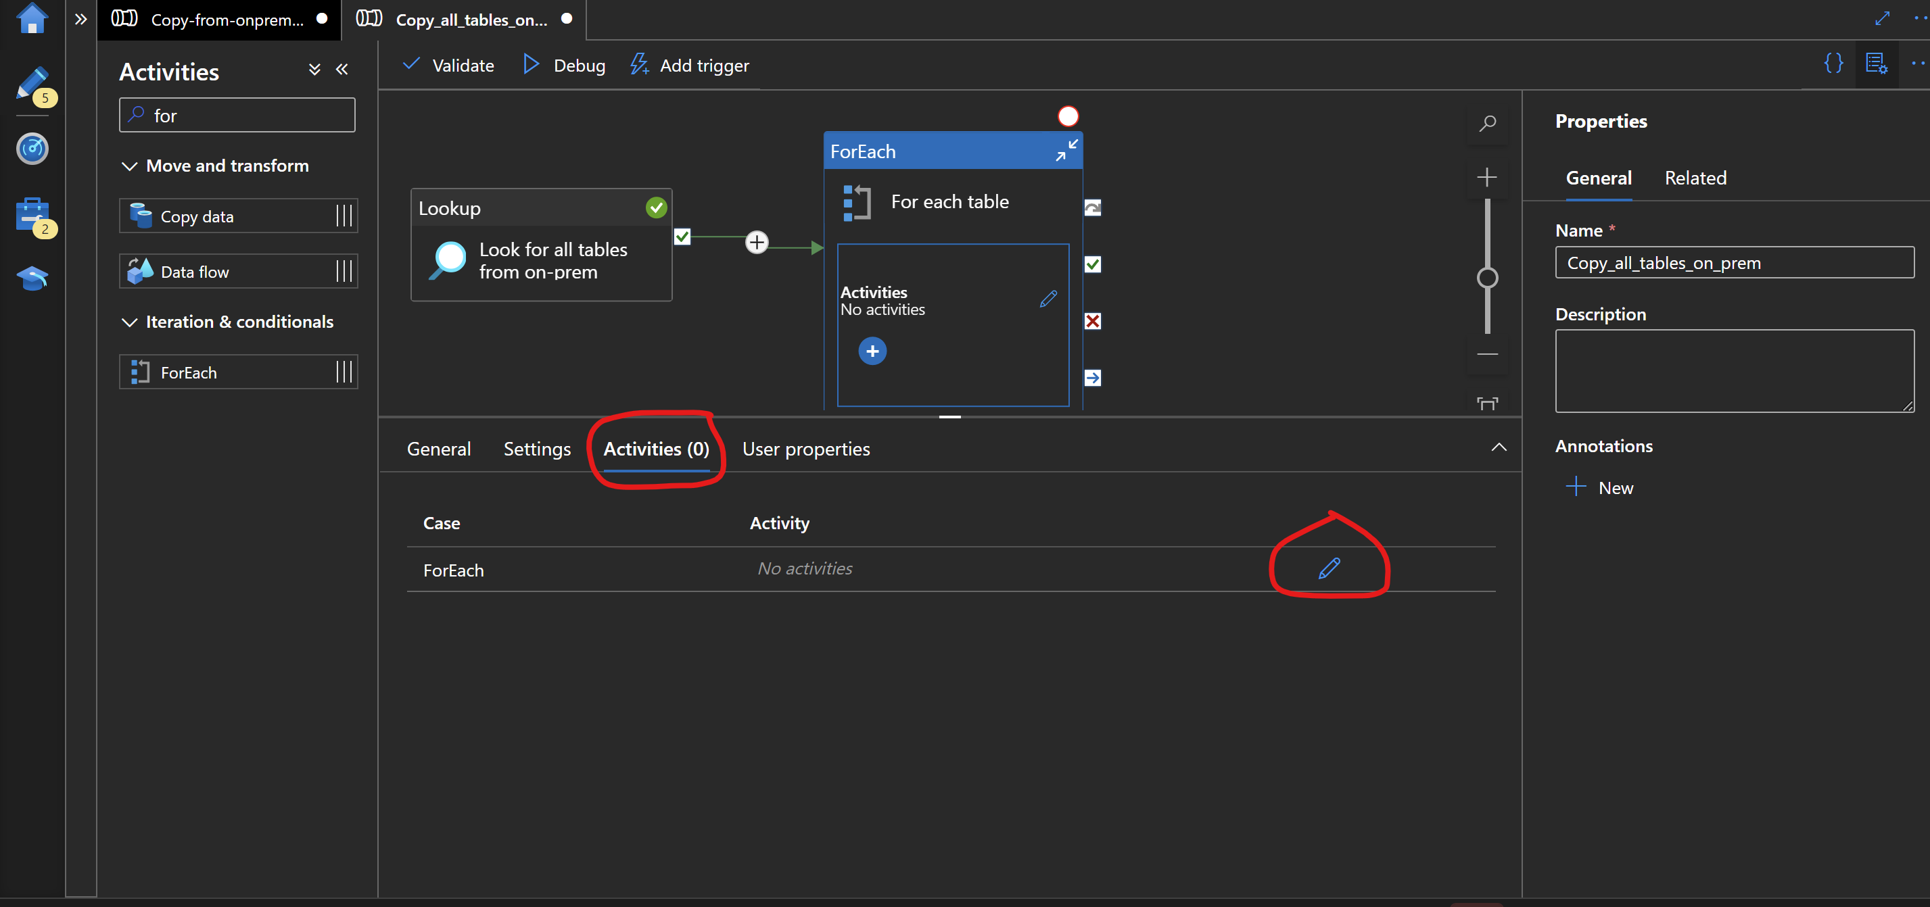

In the Edit -> Select the copy data activity -> Source -> Give the connection information of the on-prem SQL server ( Leave the table option empty )

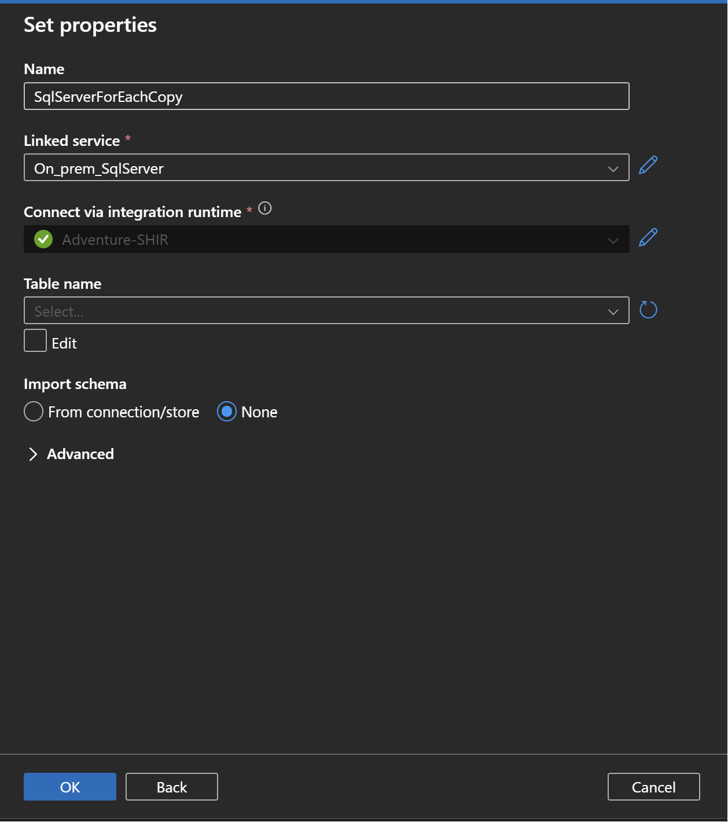

Source -> Query option -> Add dynamic content ->

@{concat('SELECT * FROM ',item().SchemaName,'.',item().TableName)}

* Configure the sink

Select azure data lake gen 2 -> Select Parquet format

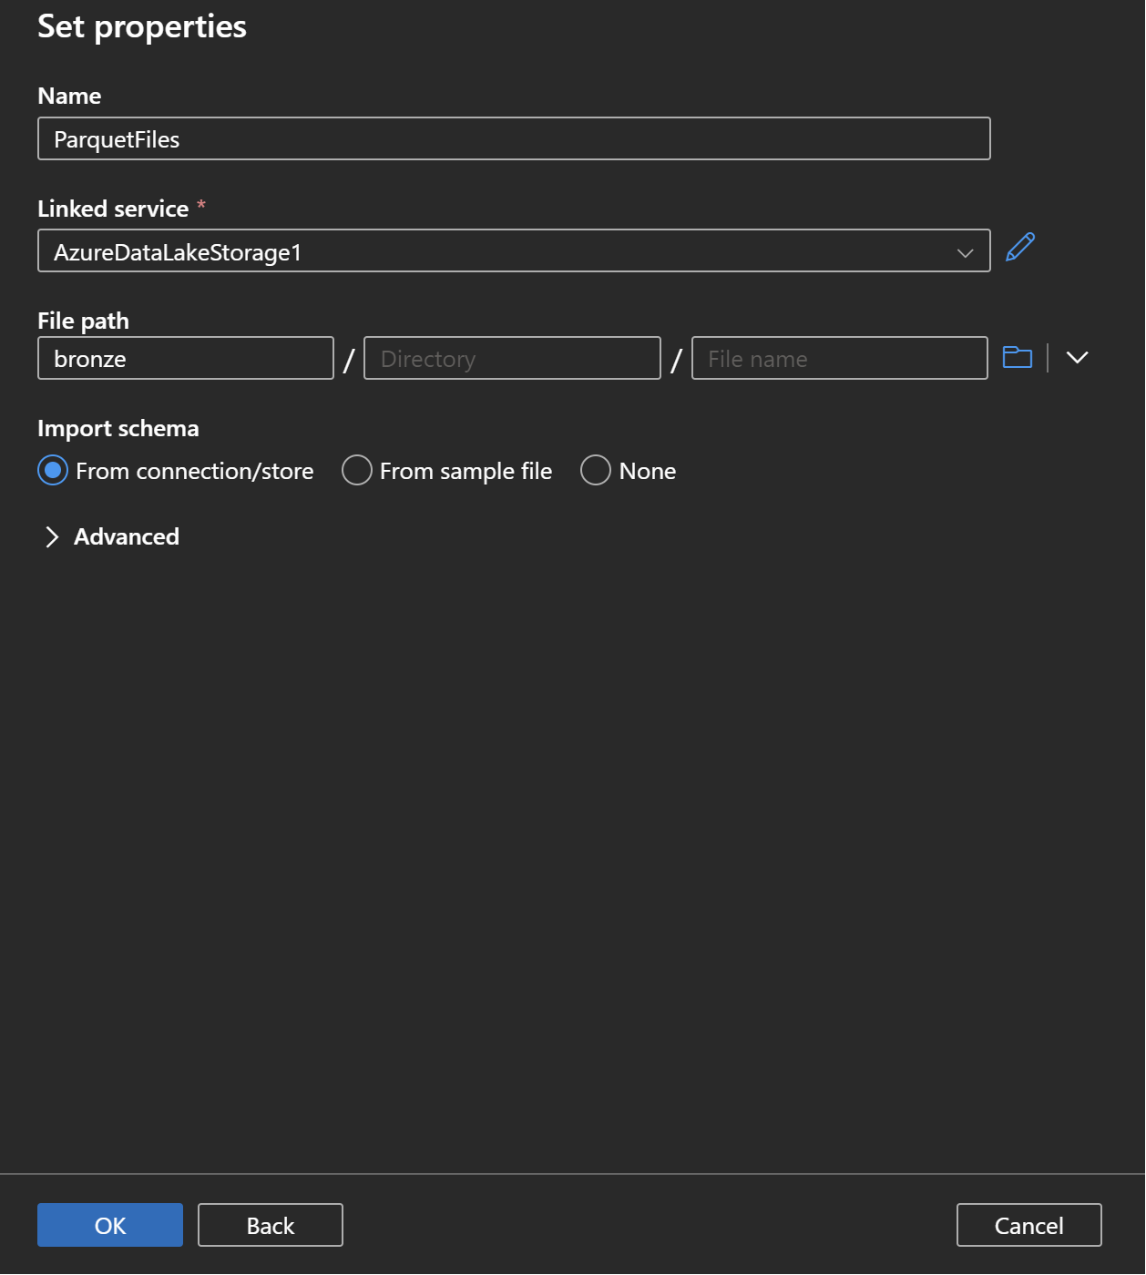

Edit the sink Properties and create a parameter.

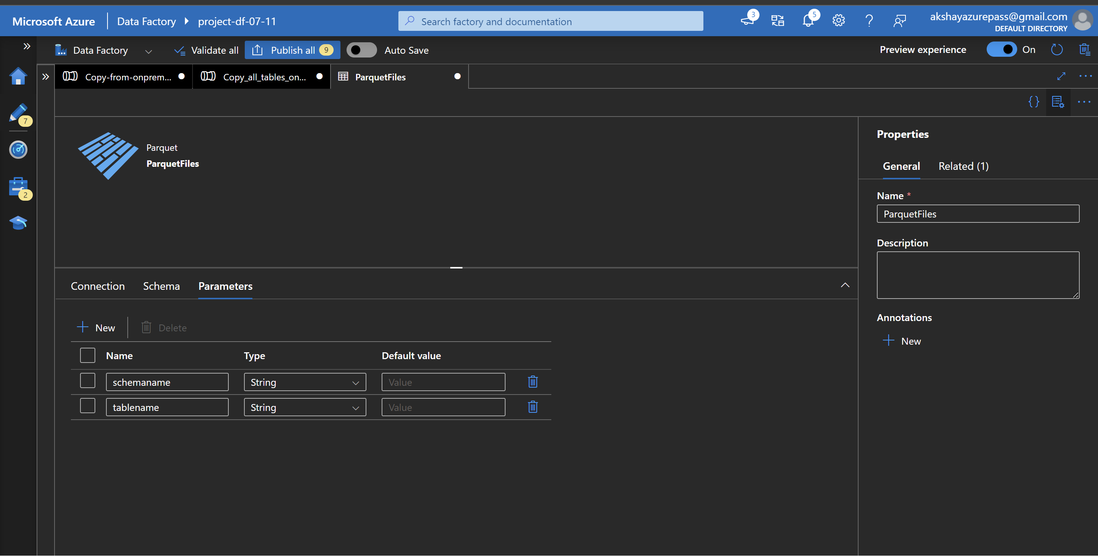

* Add the dynamic values to this parameter.

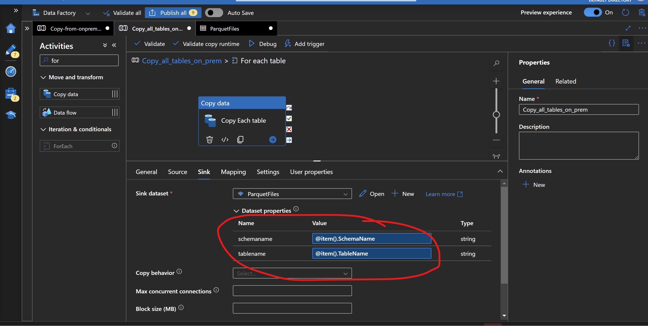

Again edit the sink properties.

In the file path option add the dynamic content ( Format : Bronze/SchemaName/TableName/filename.parquet )

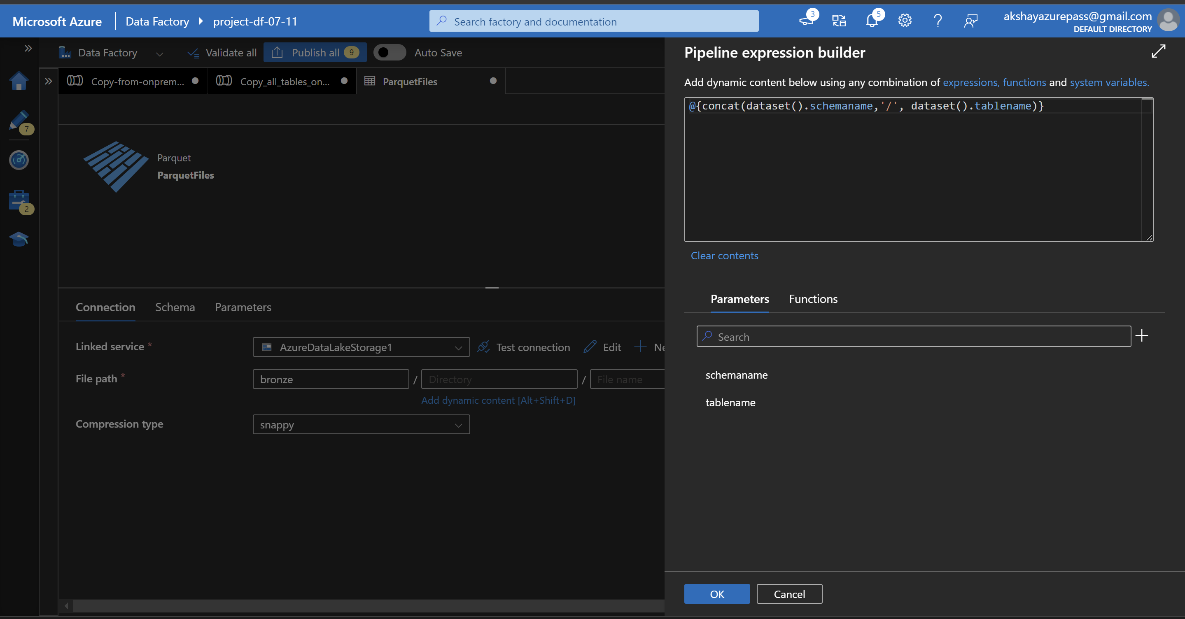

* For the file name also add the dynamic content (tablename.parquet)

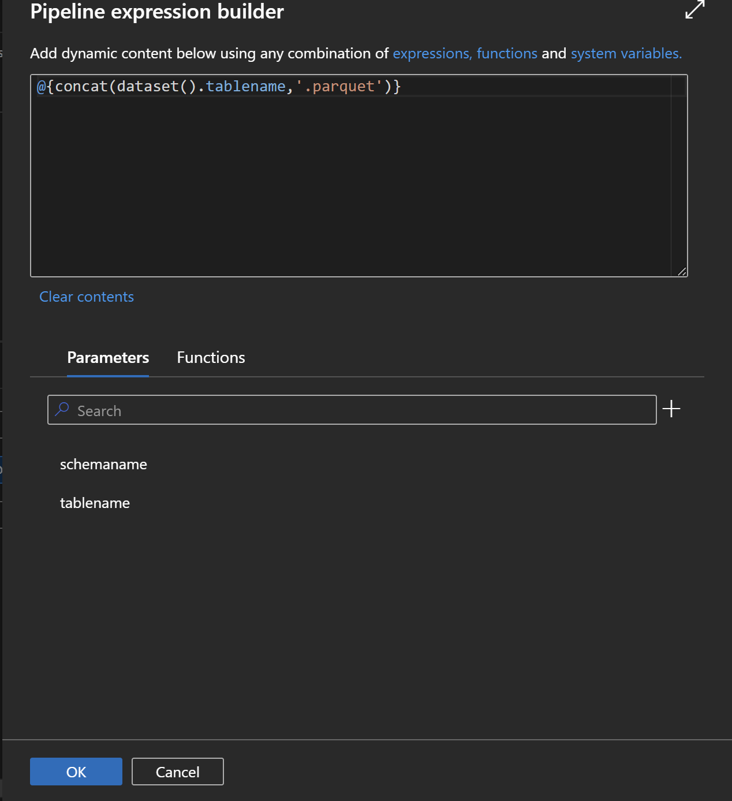

Pipeline run

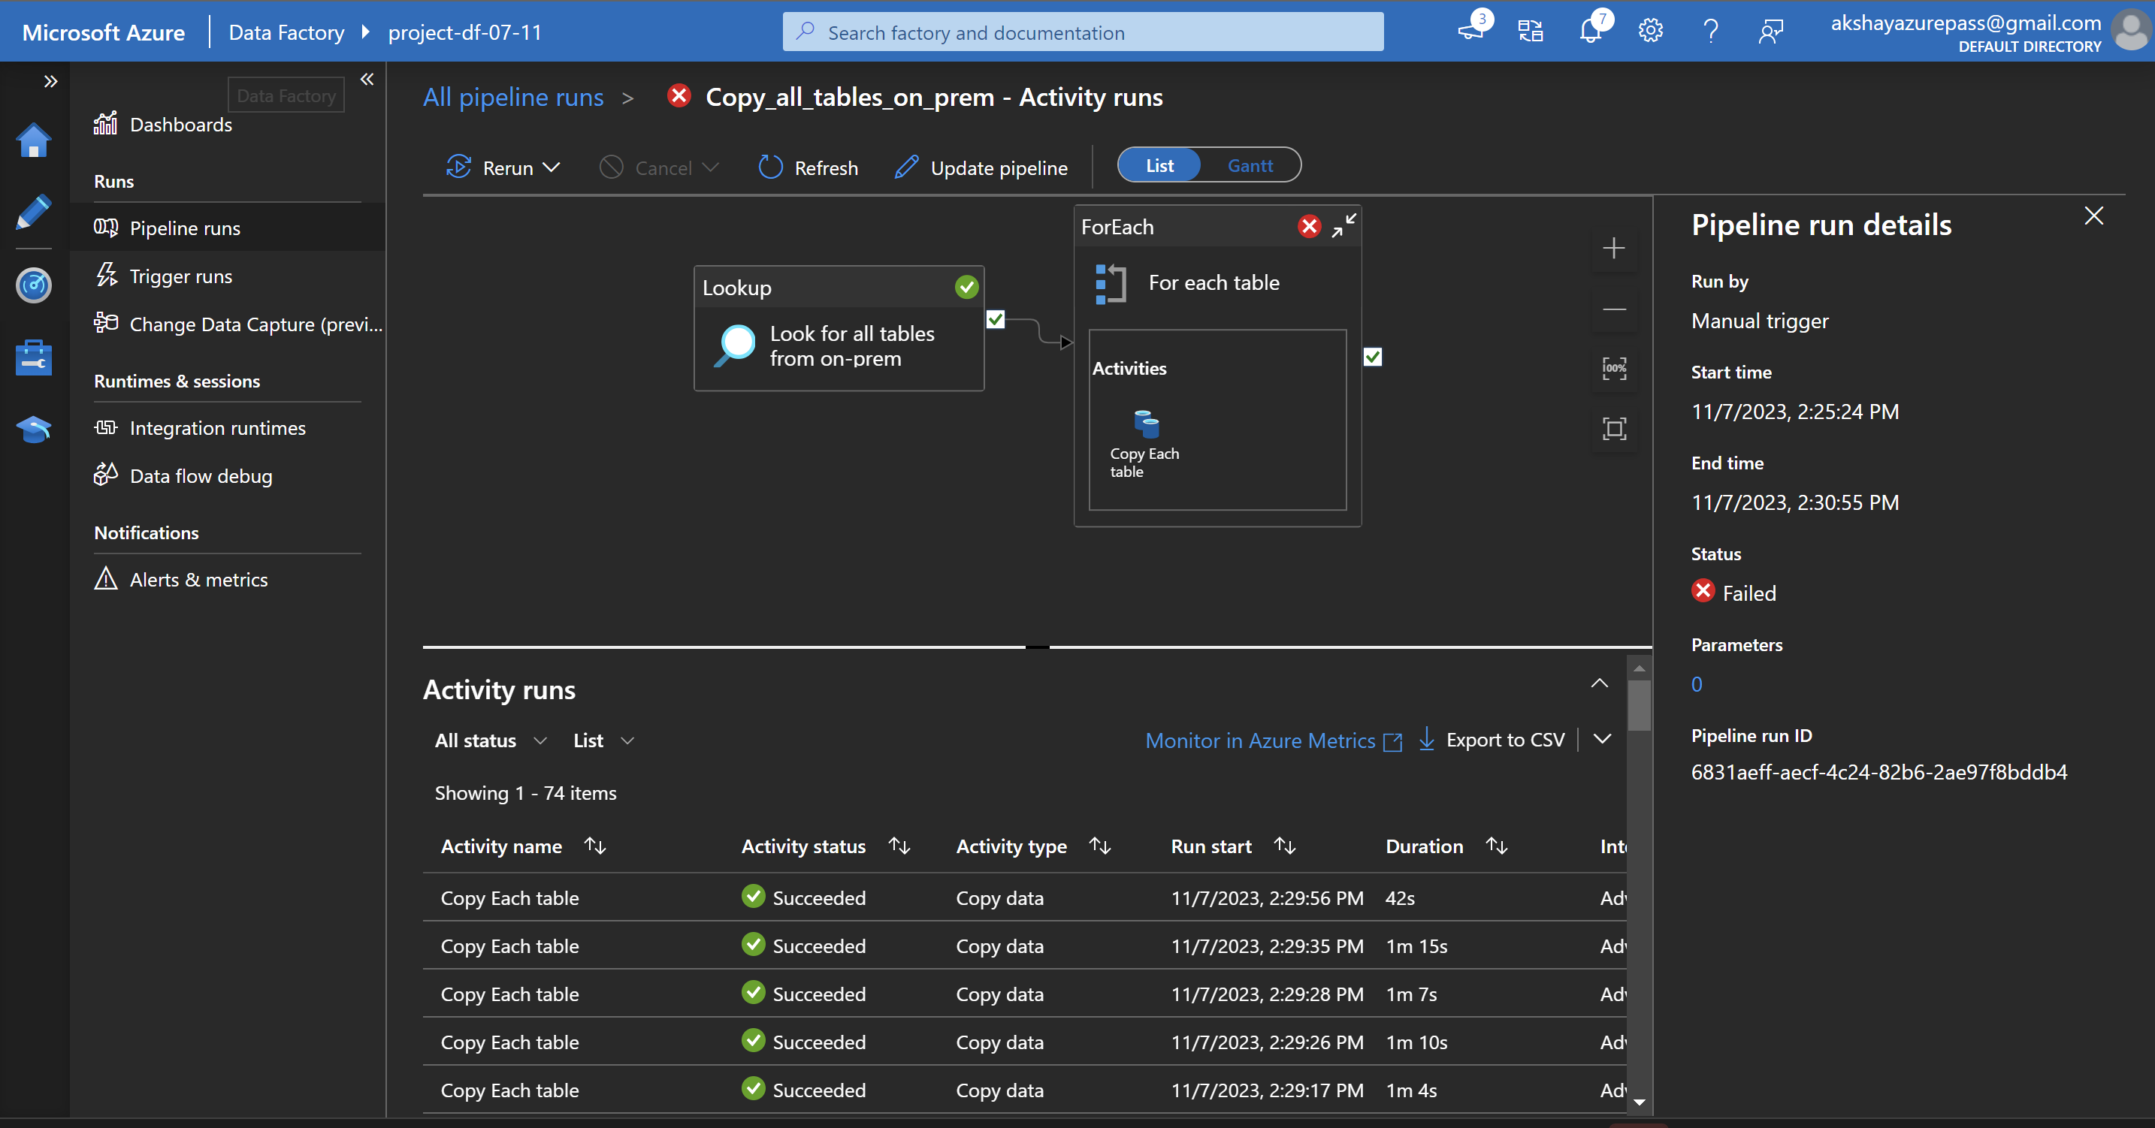

**Transformation using Azure Databricks**

* Create the app registration

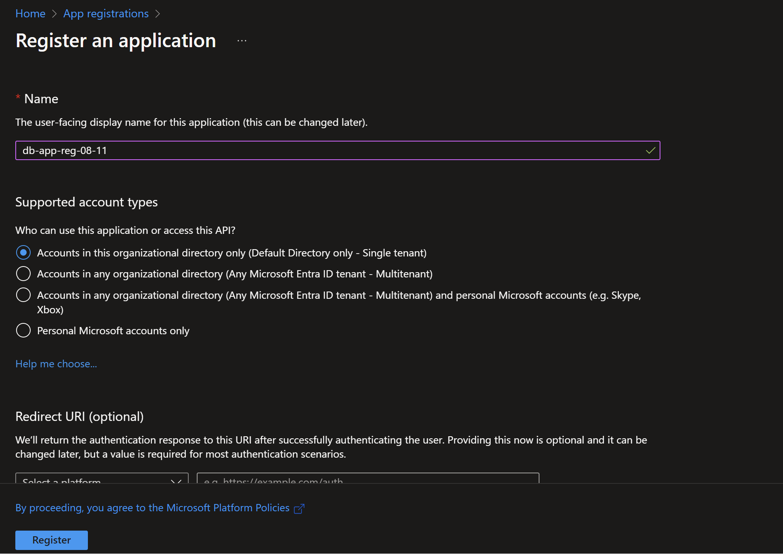

* Create a new client secret

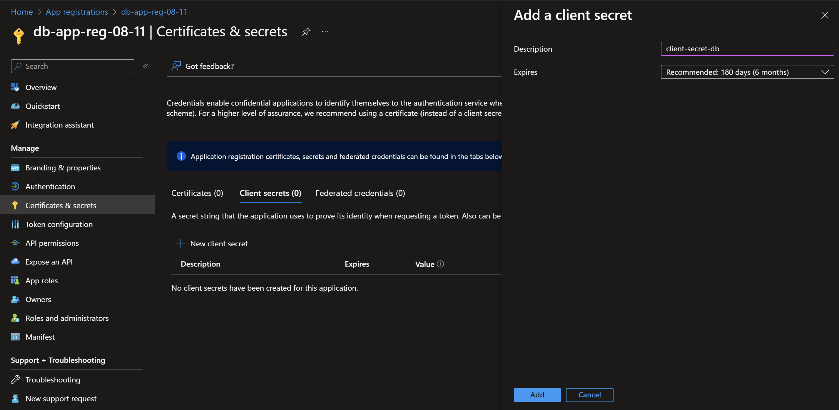

* Give the storage blob data contributor permission to the registered app

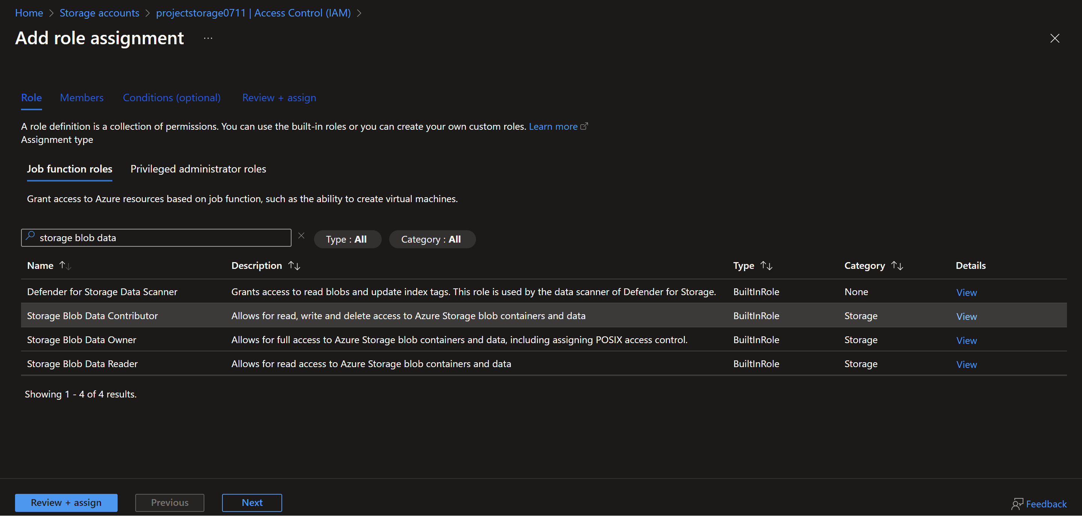

Add the registered app

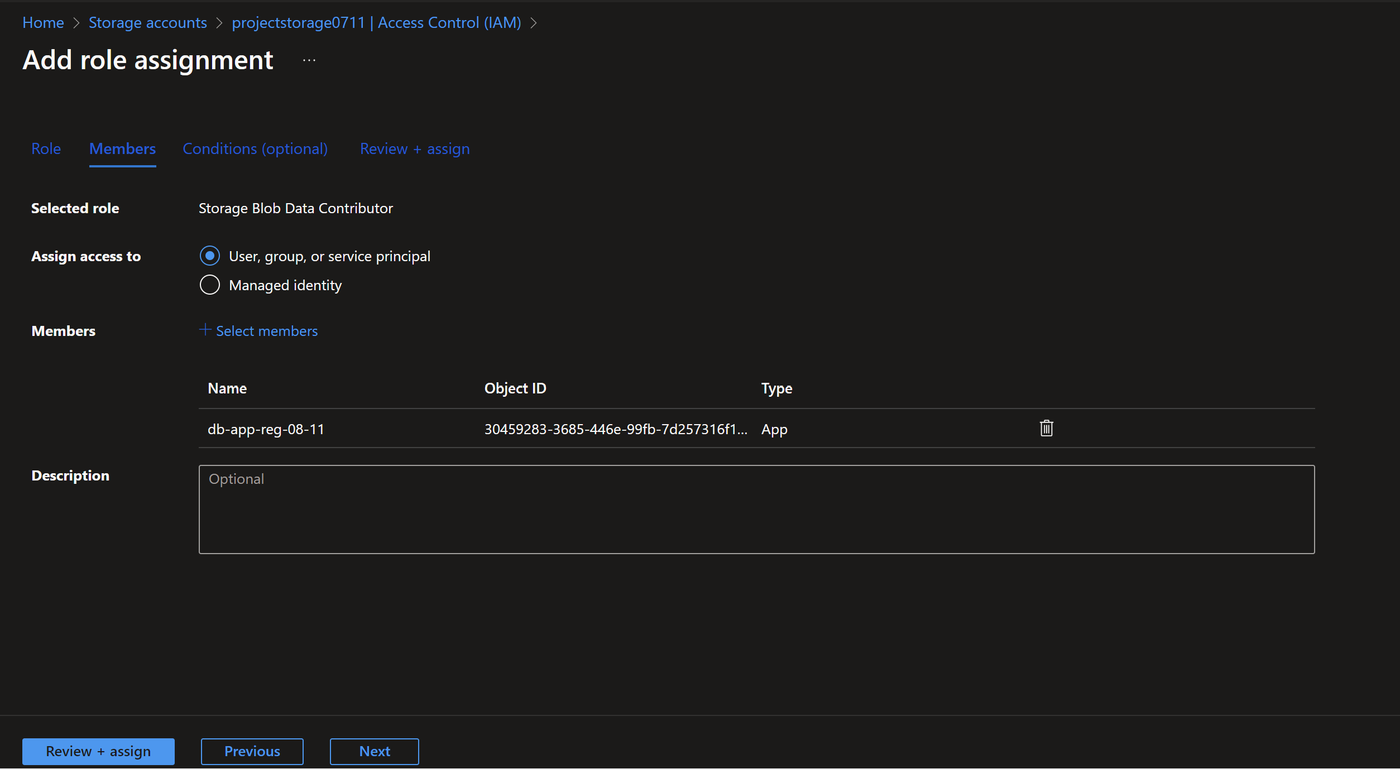

* Create a Databricks cluster and enable credential passthrough for user-level data access.
* Replace container and storage account name.
* Mount the three containers (gold, Silver, and Bronze to the azure data bricks)

**Running Azure data bricks as a job using Azure Data Factory.**

Create a new Linked service -> Select data bricks from the compute tab

* We need an access token to access the Databricks

Databricks -> User Settings -> Developer -> Generate new access token

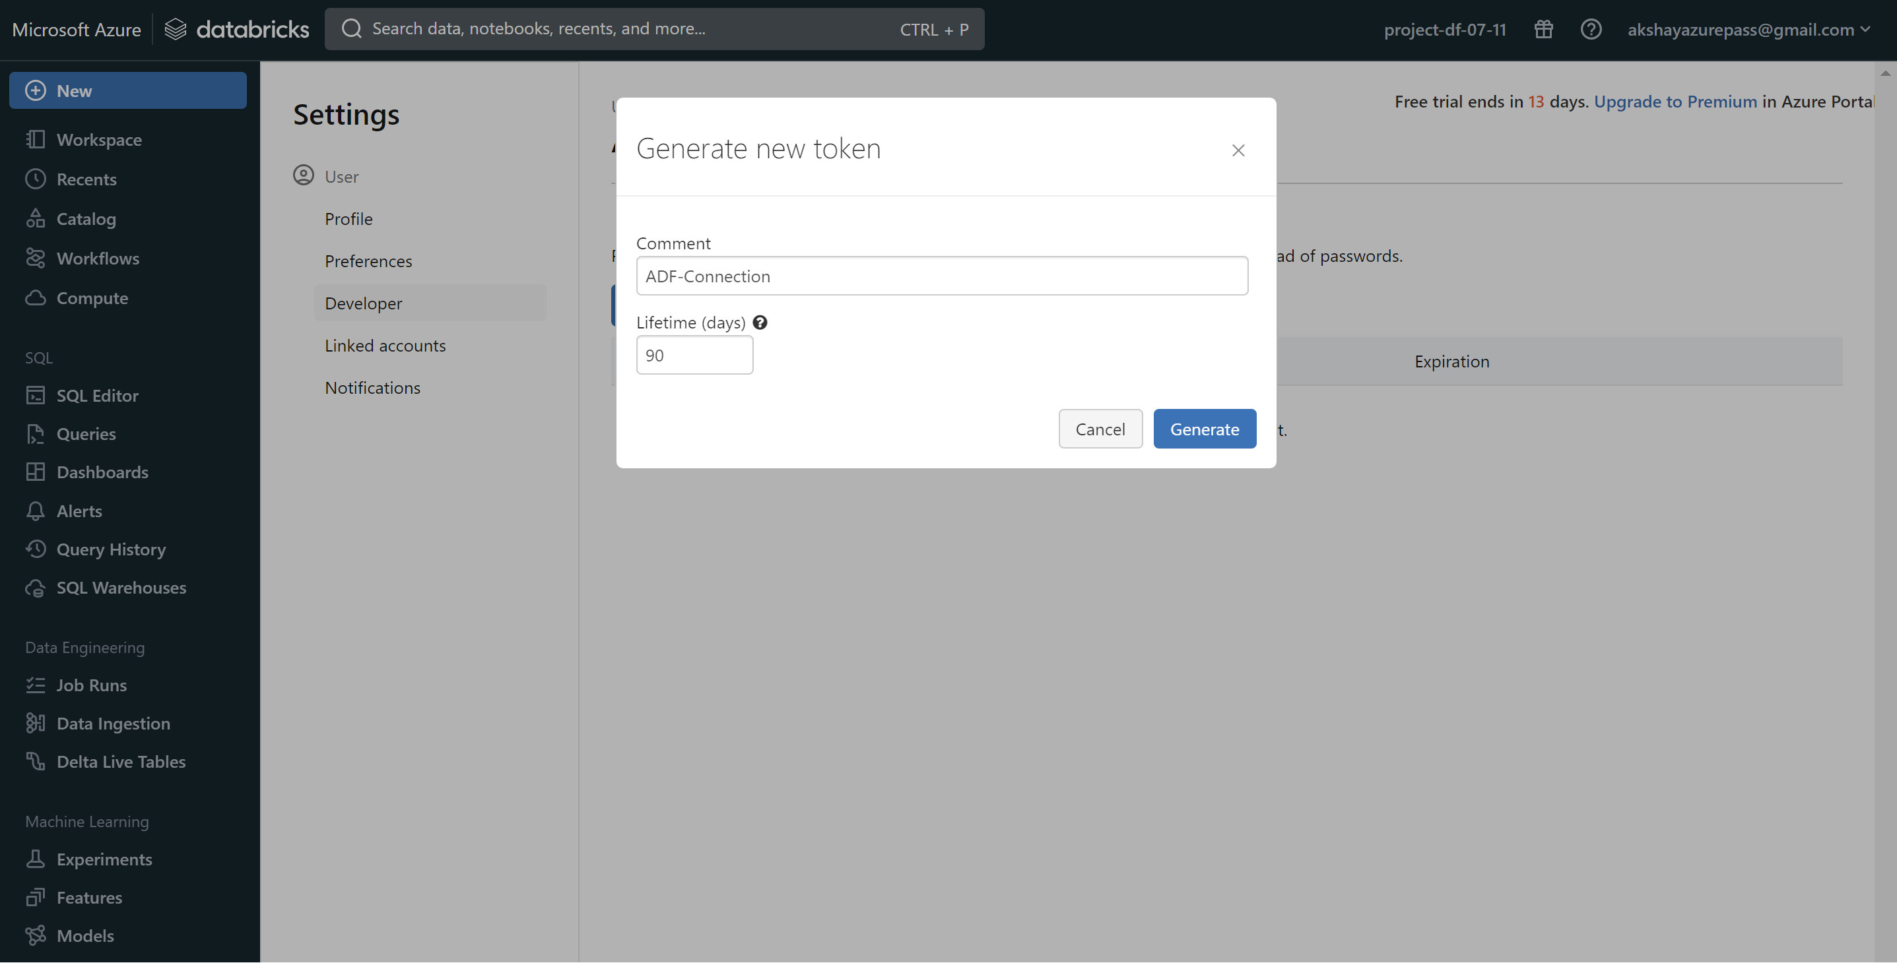

Store this token in the Azure key vault.

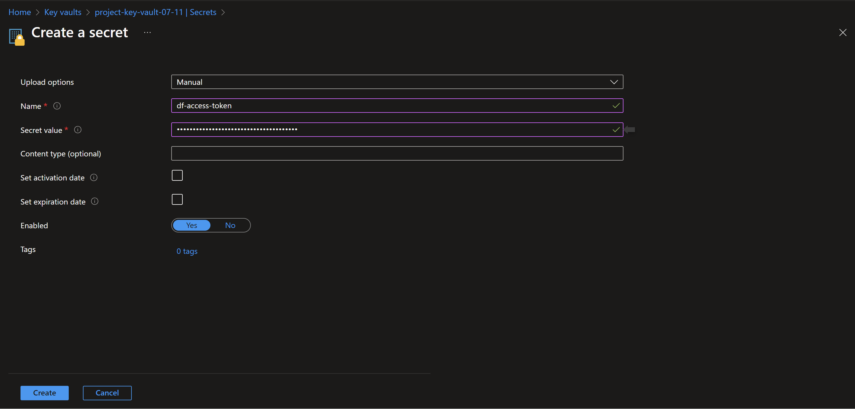

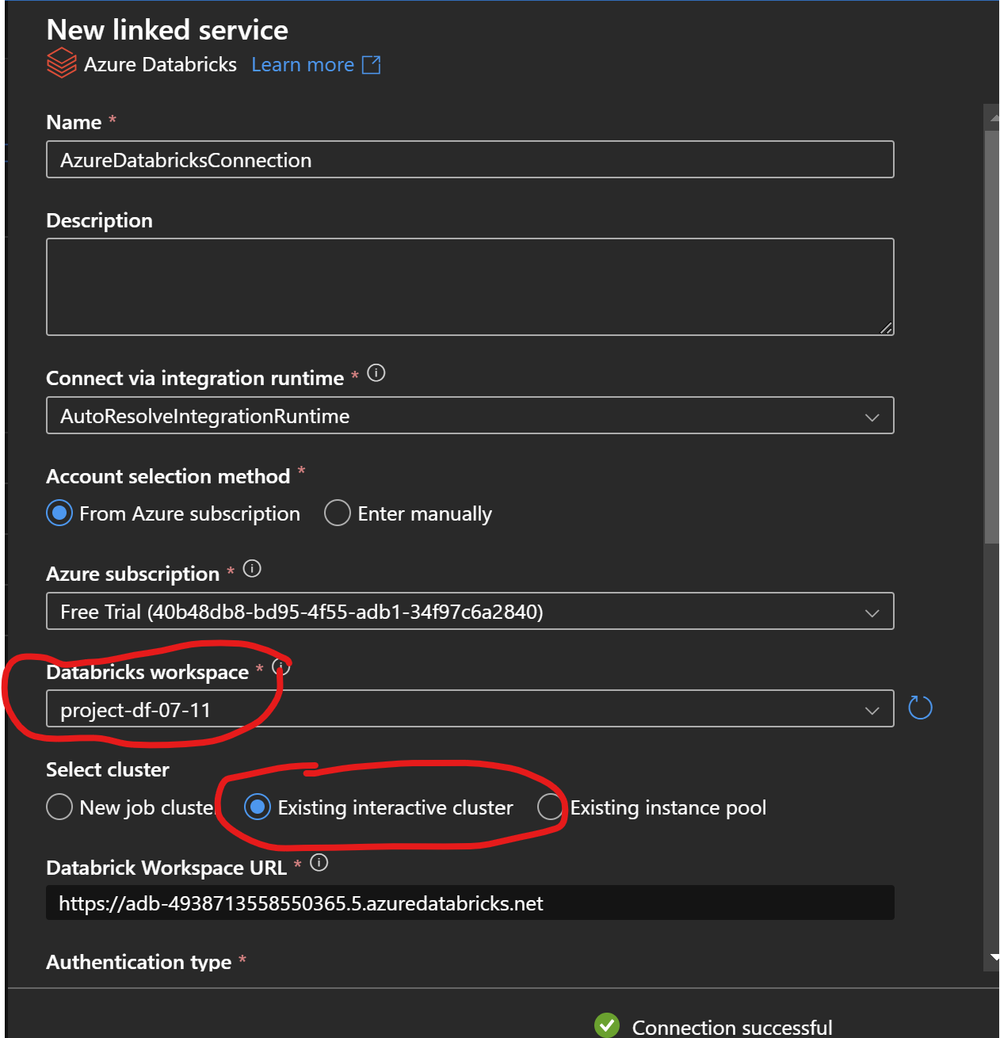

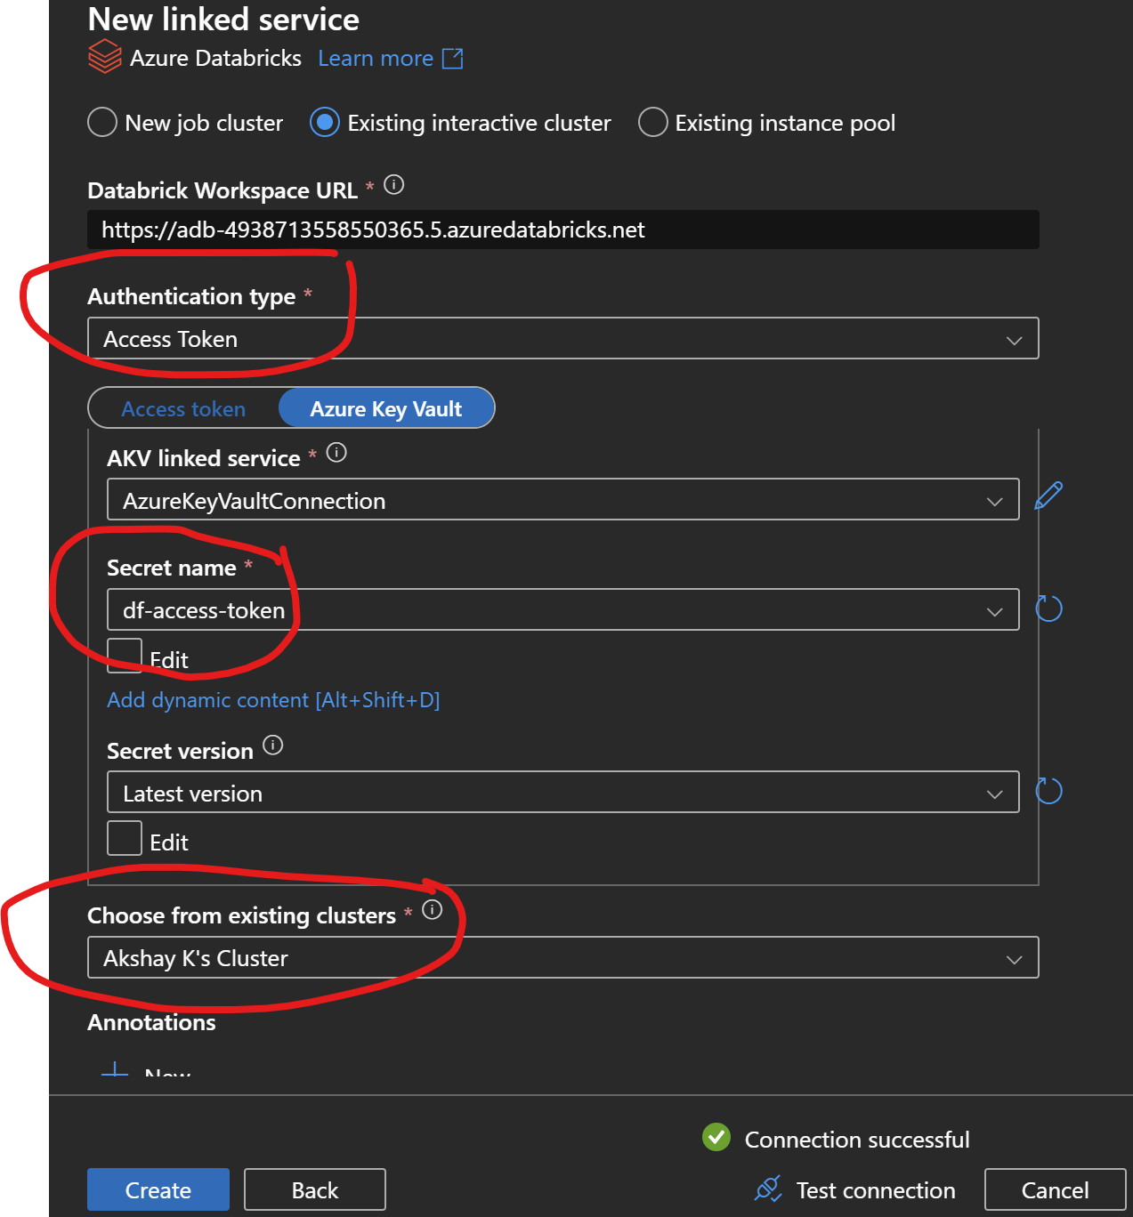

* In the existing pipeline use the notebook activity.
* Select the data bricks notebook

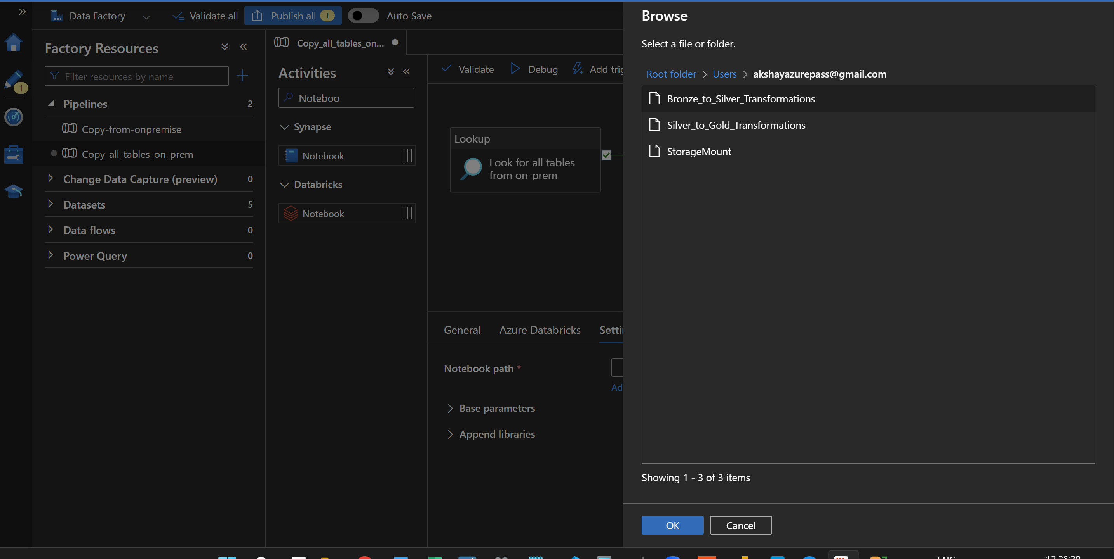

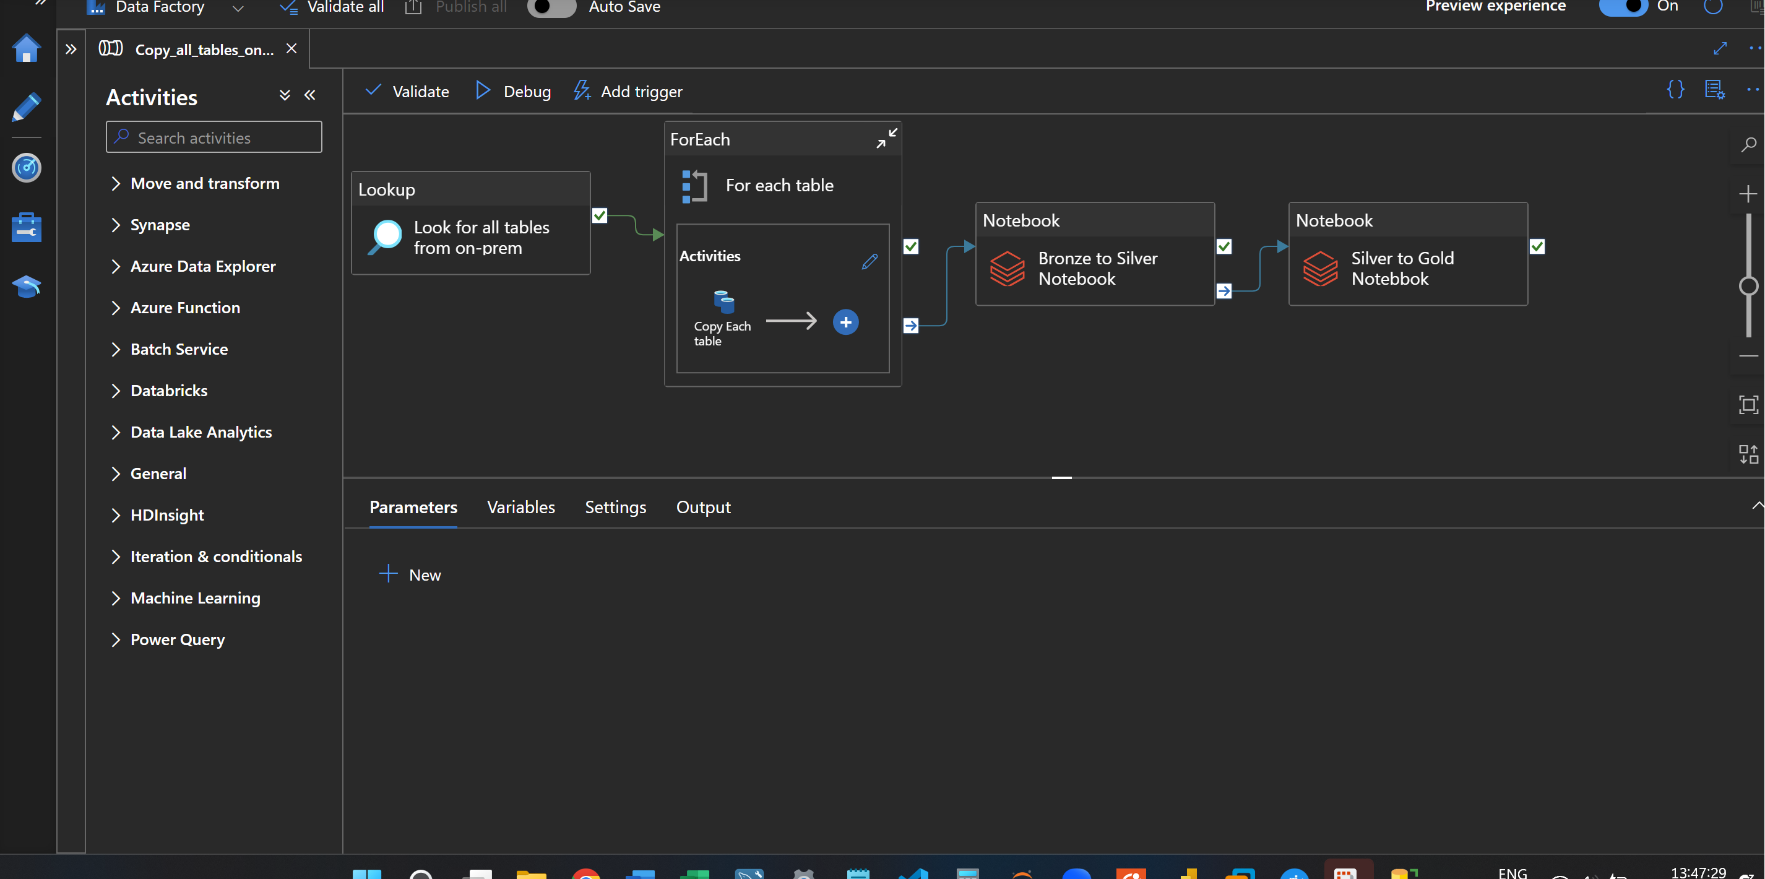

* Run the entire pipeline together

**Analyzing the data using Azure Synapse Analytics:**

Create a new SQL DB

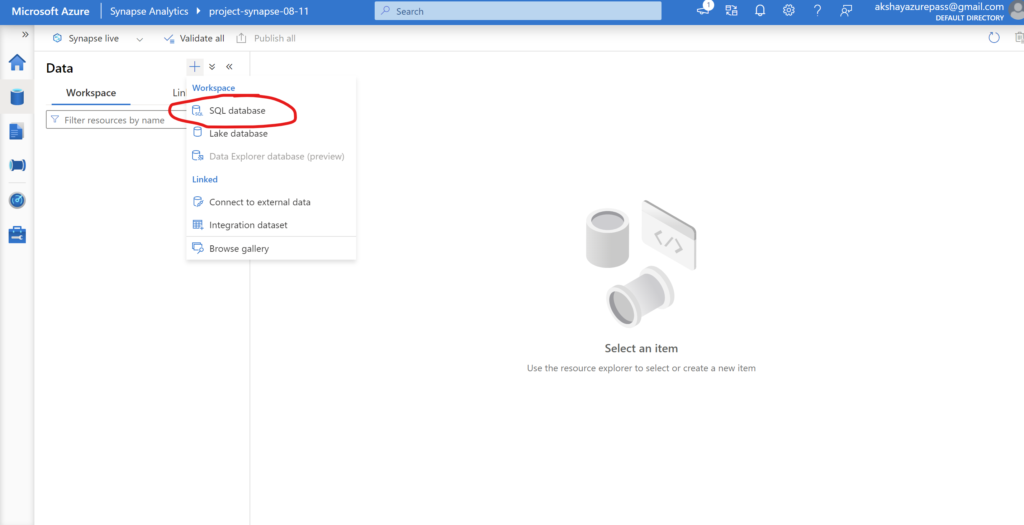

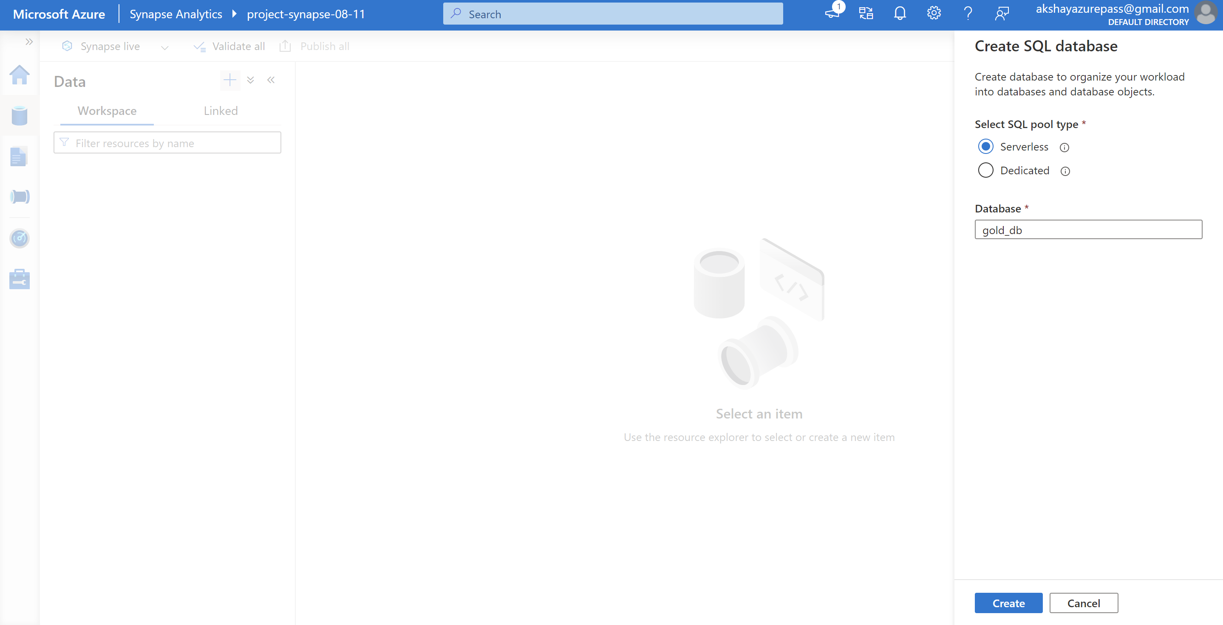

* Using a Serverless SQL pool, we can directly query the data which is present in the Azure ADLS. It uses only the compute.
* But if we use a Dedicated SQL Pool, we need to load the data from ADLS into the synapse table. It uses both storage and compute.
* Select top 100 rows

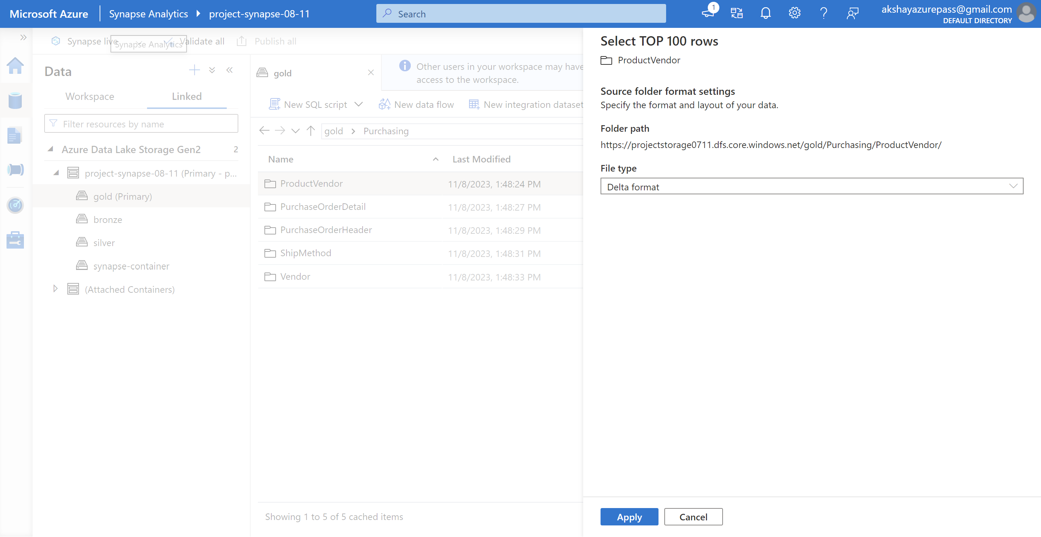

* Create a view in the GoldDB database

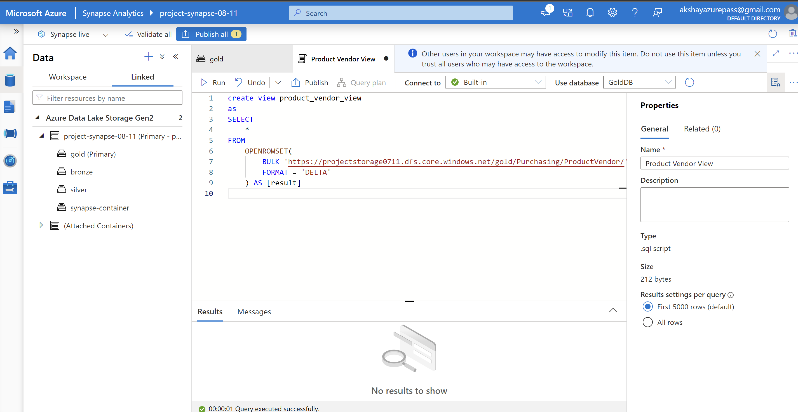

* Create a view for all the tables in the gold container by building the pipeline in the synapse
* Create a stored procedure to create a view dynamically
* Create a new linked connection

New SQL Database -> Account Selection Method -> Enter manually -> Enter Database name

Authentication type -> System Assigned managed identity

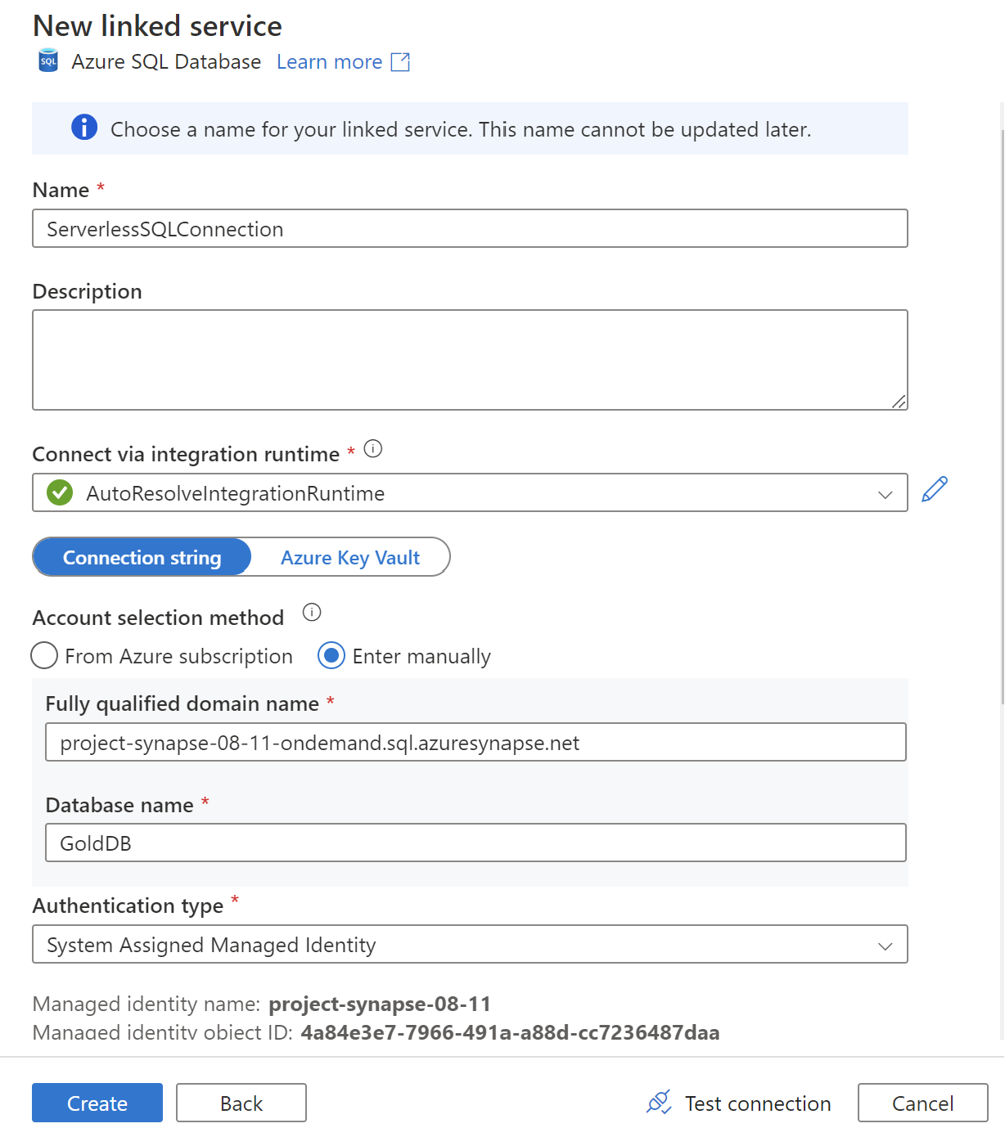

Get the details from properties -> Serverless SQL Endpoint

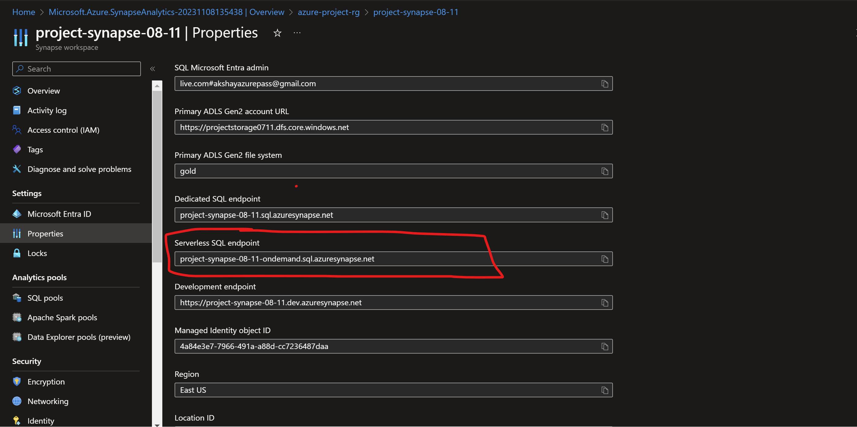

* Create a new pipeline in the synapse
* Use the Get Metadata activity – to get all the table names
* Settings -> New -> Data lake gen 2-> Choose the binary format
* The linked service is automatically created when we create a synapse. This will create a connection between the Azure ADLS and the Synapse

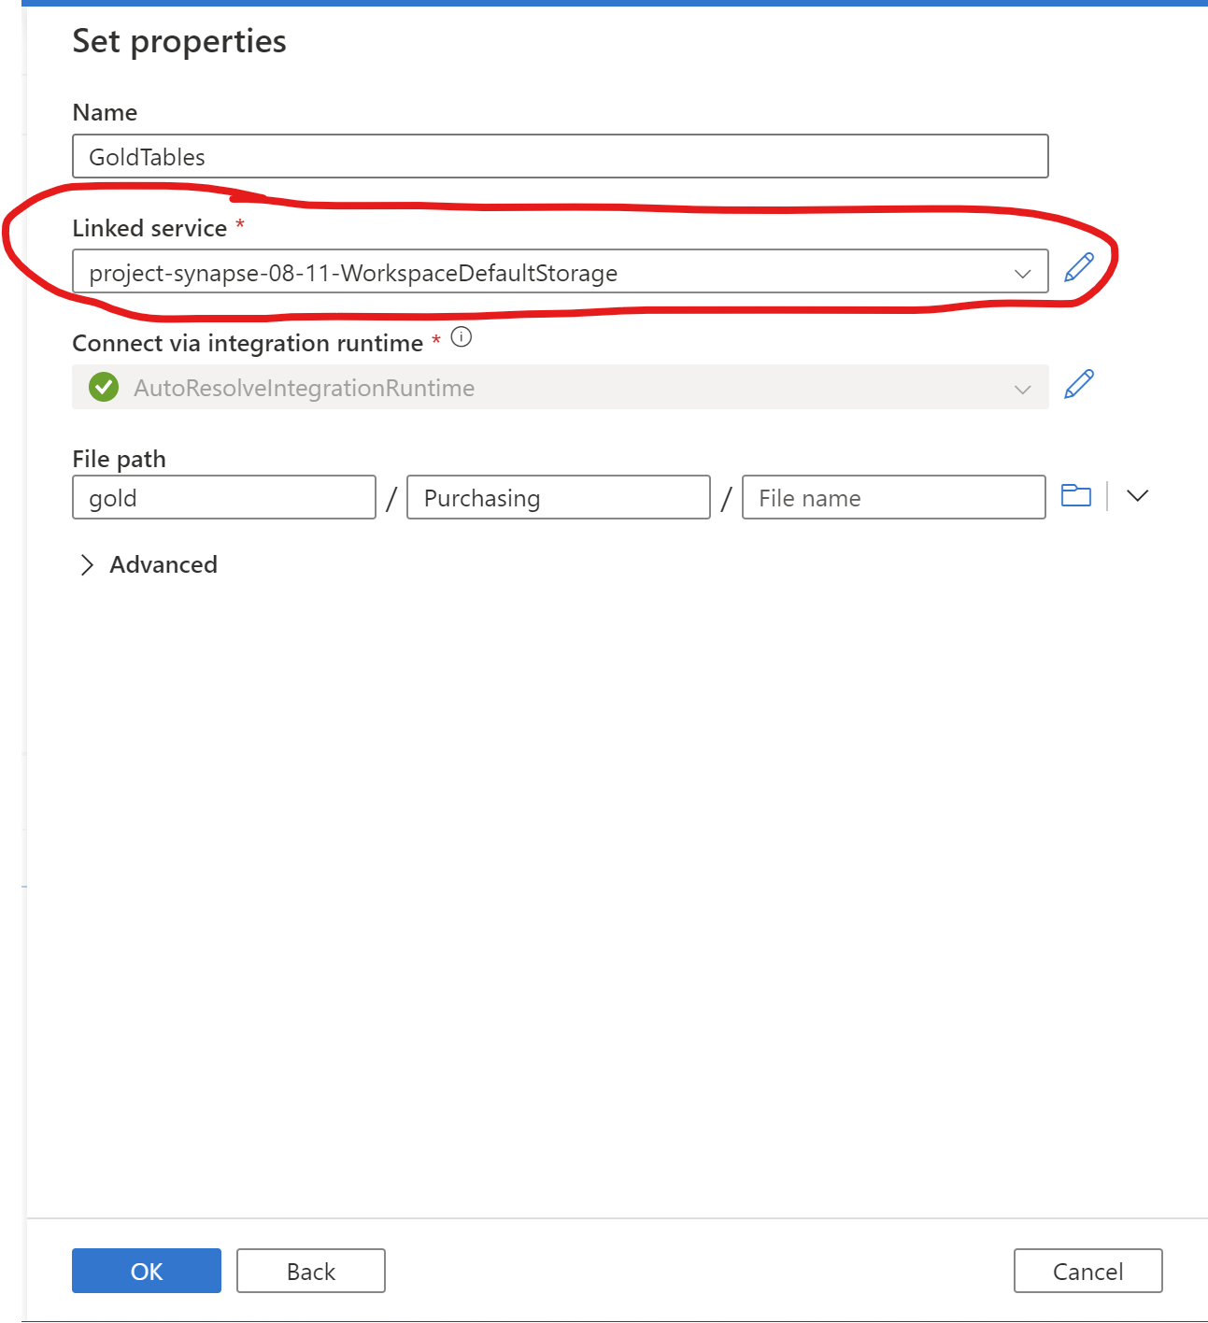

In the field list select the child items

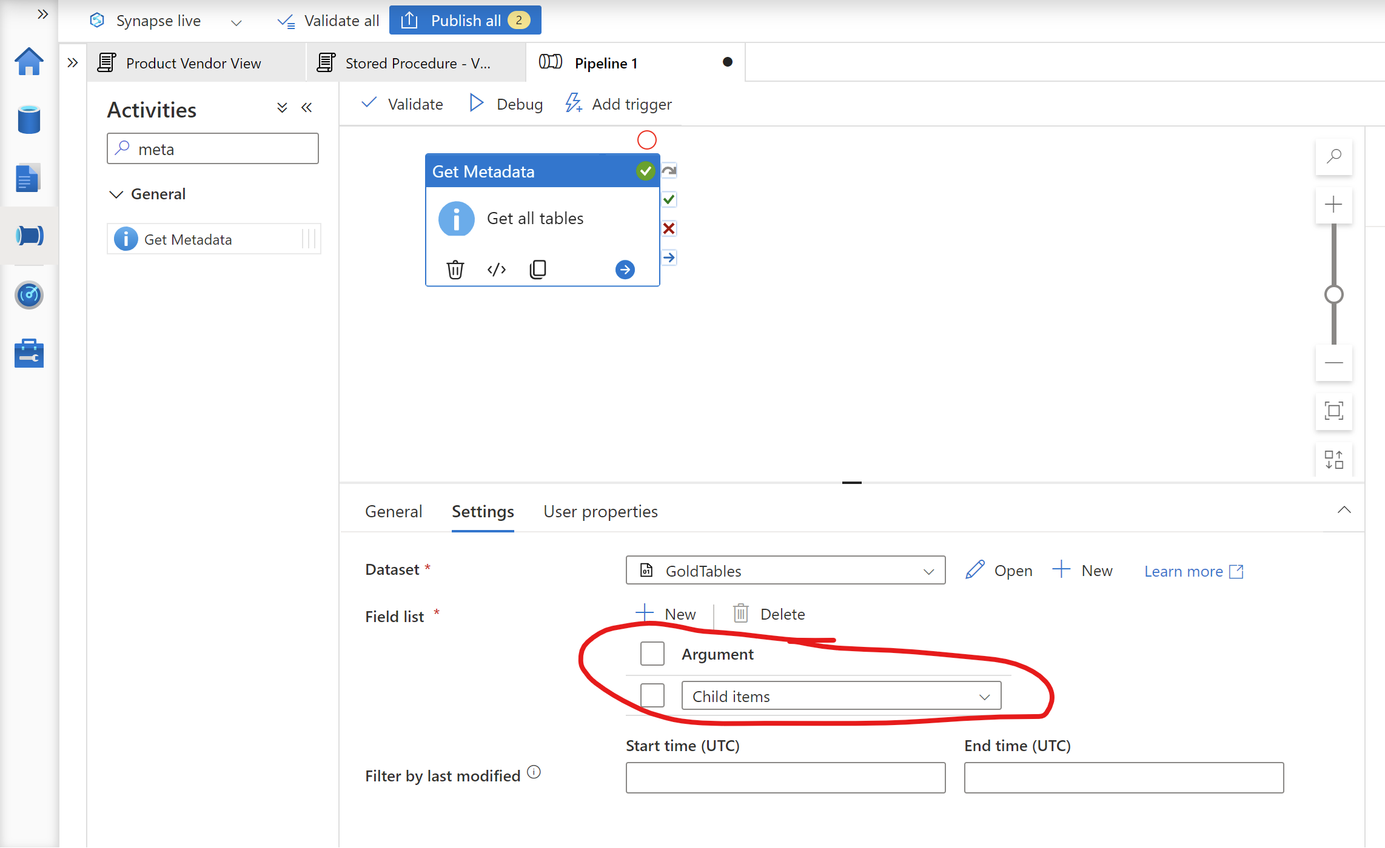

* Next use the for each activity to process the all the table names
* In the settings tab add the dynamic content

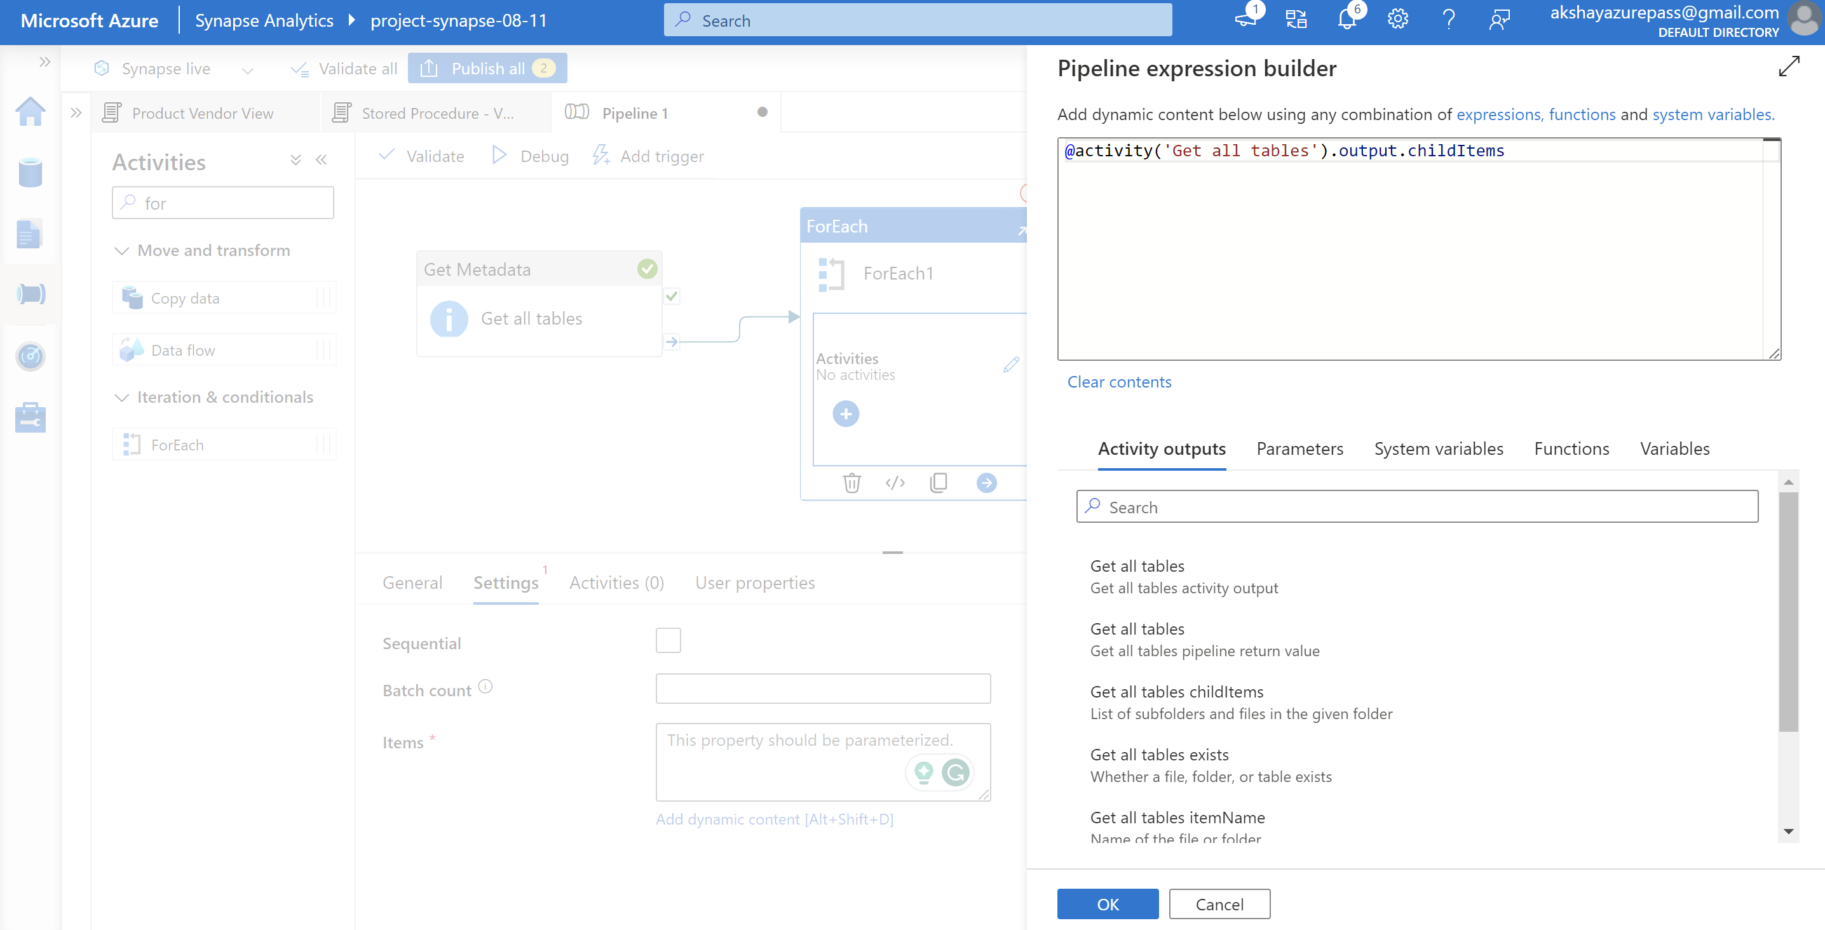

* Edit the for each activity:
* Use the stored Procedure

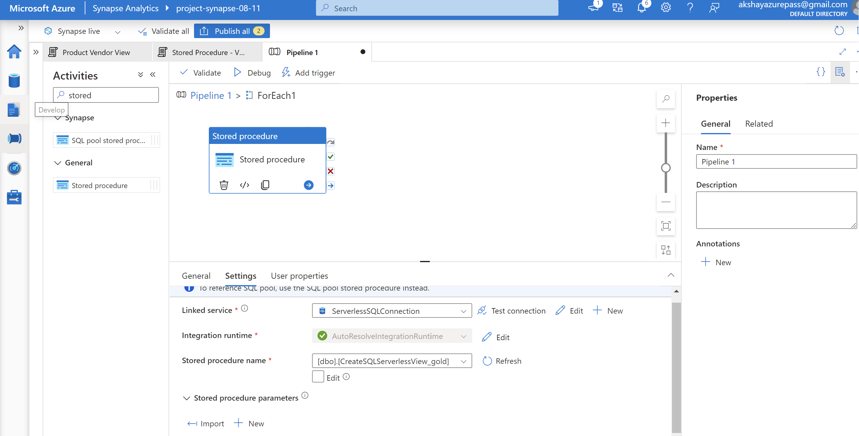

Create a new stored procedure parameter:

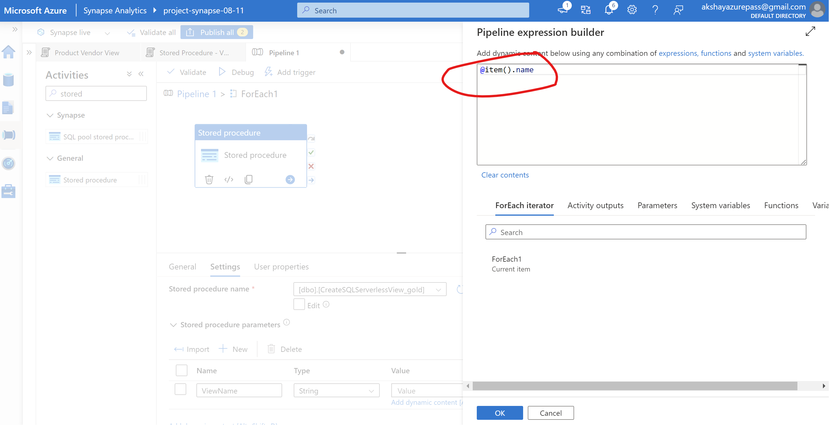

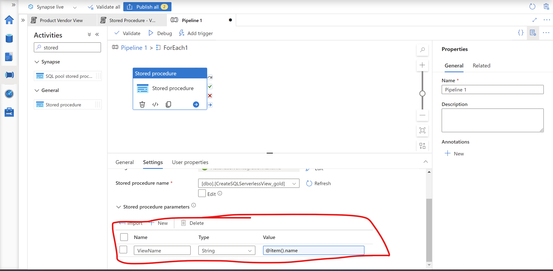

* Run the pipeline, this will create a view of all the tables in a gold container

**Reporting using PowerBI**

Get data -> Azure -> Synapse Analytics

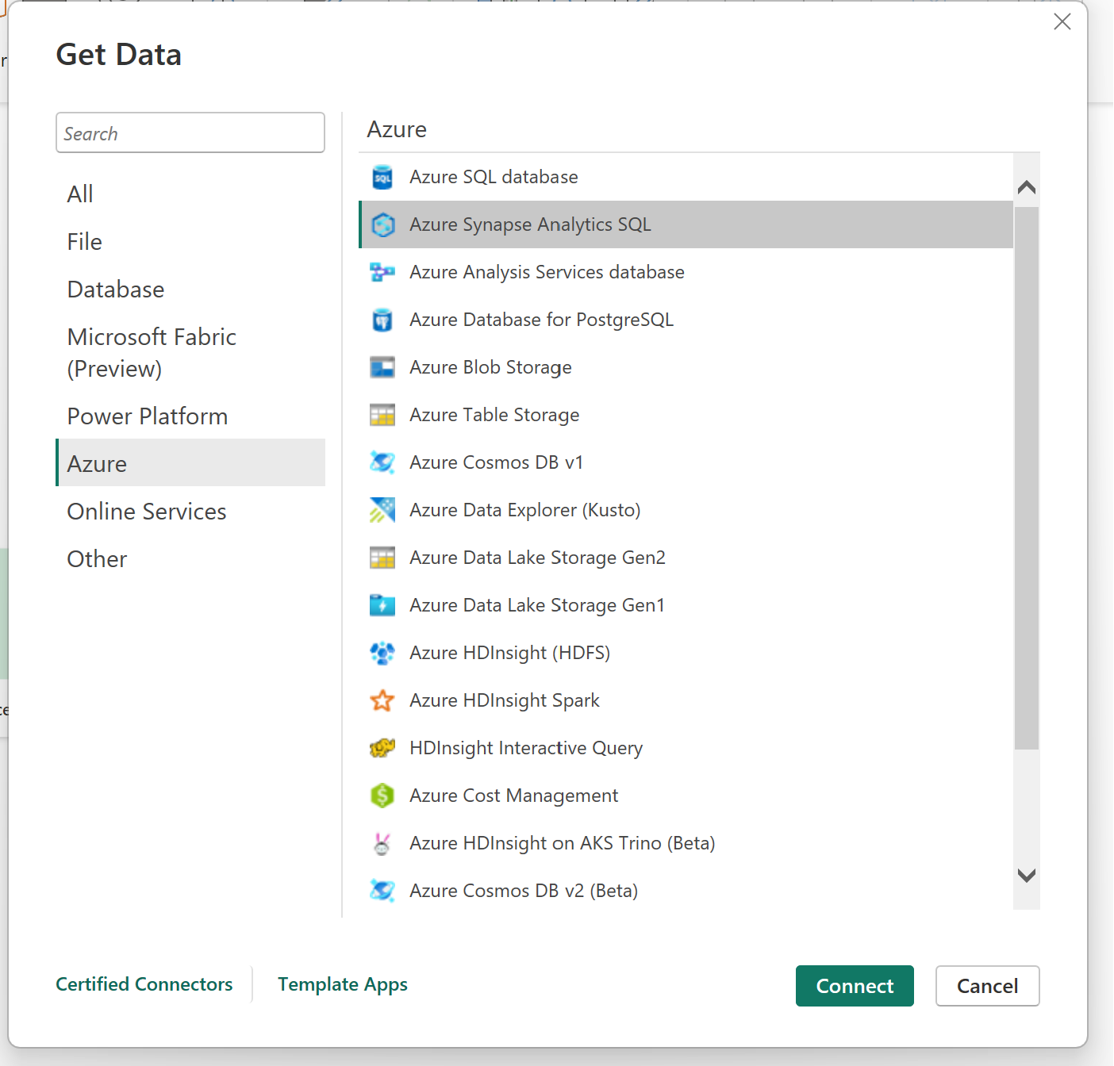

Use the serverless sql endpoint

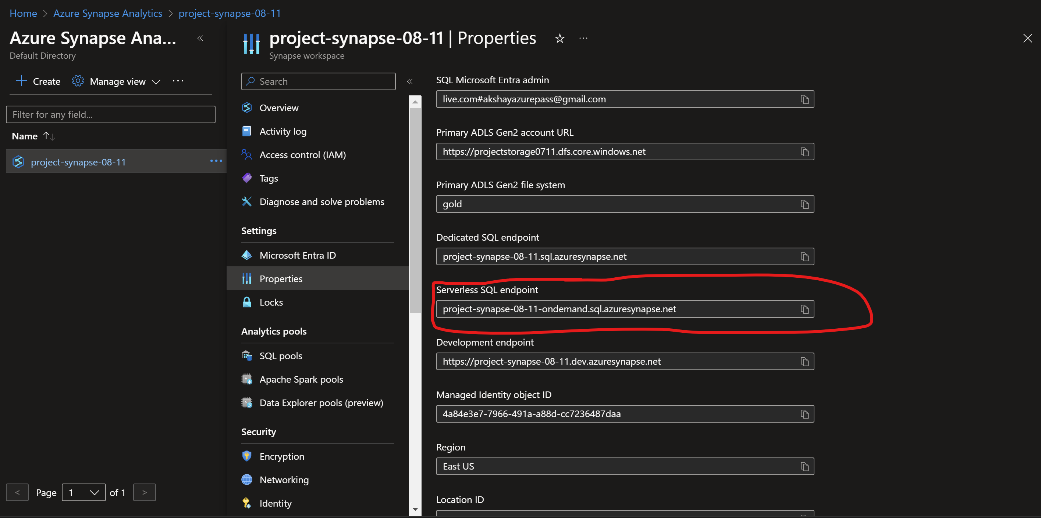

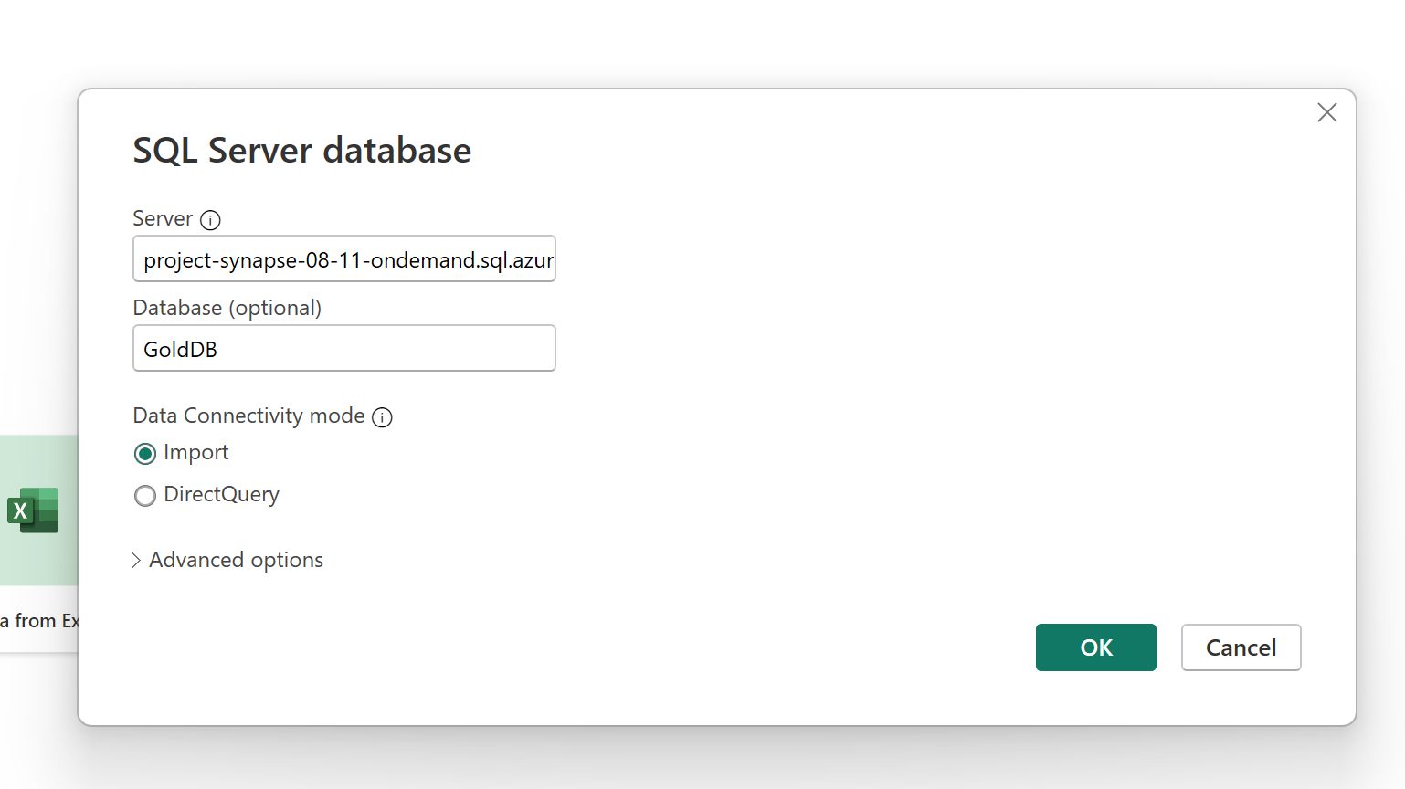

* Select Microsoft account for authentication method.
* Load all the views into PowerBI

**Azure Active directory :**

* Create a new group within Entra ID
* Select the owners and members

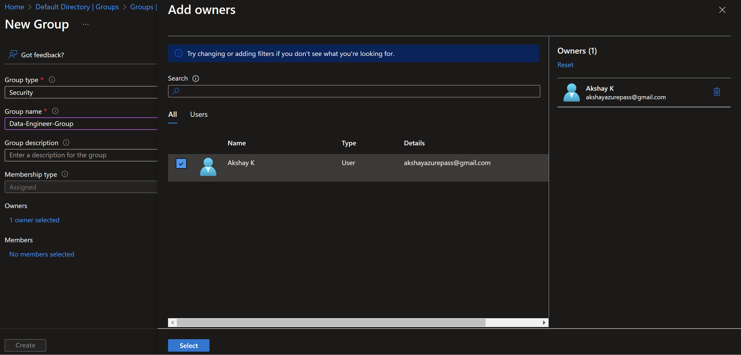

* In the storage account, Create a new role assignment
* Assign the contributor role to the security group

